周会

目录

一、主要资产类别回顾 3

二.主要板块回顾 4

1.总体概览 4

1)Index Review 4

2)Market Summary 4

3)Duration Matrix 7

2.HY Property 7

1)Index Review 7

2)HY Property Summary 9

3)Duration Matrix 11

3.IG Corporate 11

1)Index Review 11

2)IG Corporate Summary 12

3)Duration Matrix 14

4.Financials 15

1)Index Review 15

2)Financials Summary 16

3)Duration Matrix 18

5.LGFV 19

1)Index Review 19

2)LGFV Summary 20

6.Industry 22

1)Index Review 22

2)Industry Summary 23

7.Bank Capital 25

1)Index Review 25

2)AT1 Summary 27

3)Tier2 Summary 29

8.EM 31

1)Index Review 31

2)EM Summary 32

3)Duration Matrix 34

# 一、主要资产类别回顾

图1: 主要资产近一周涨跌幅汇总

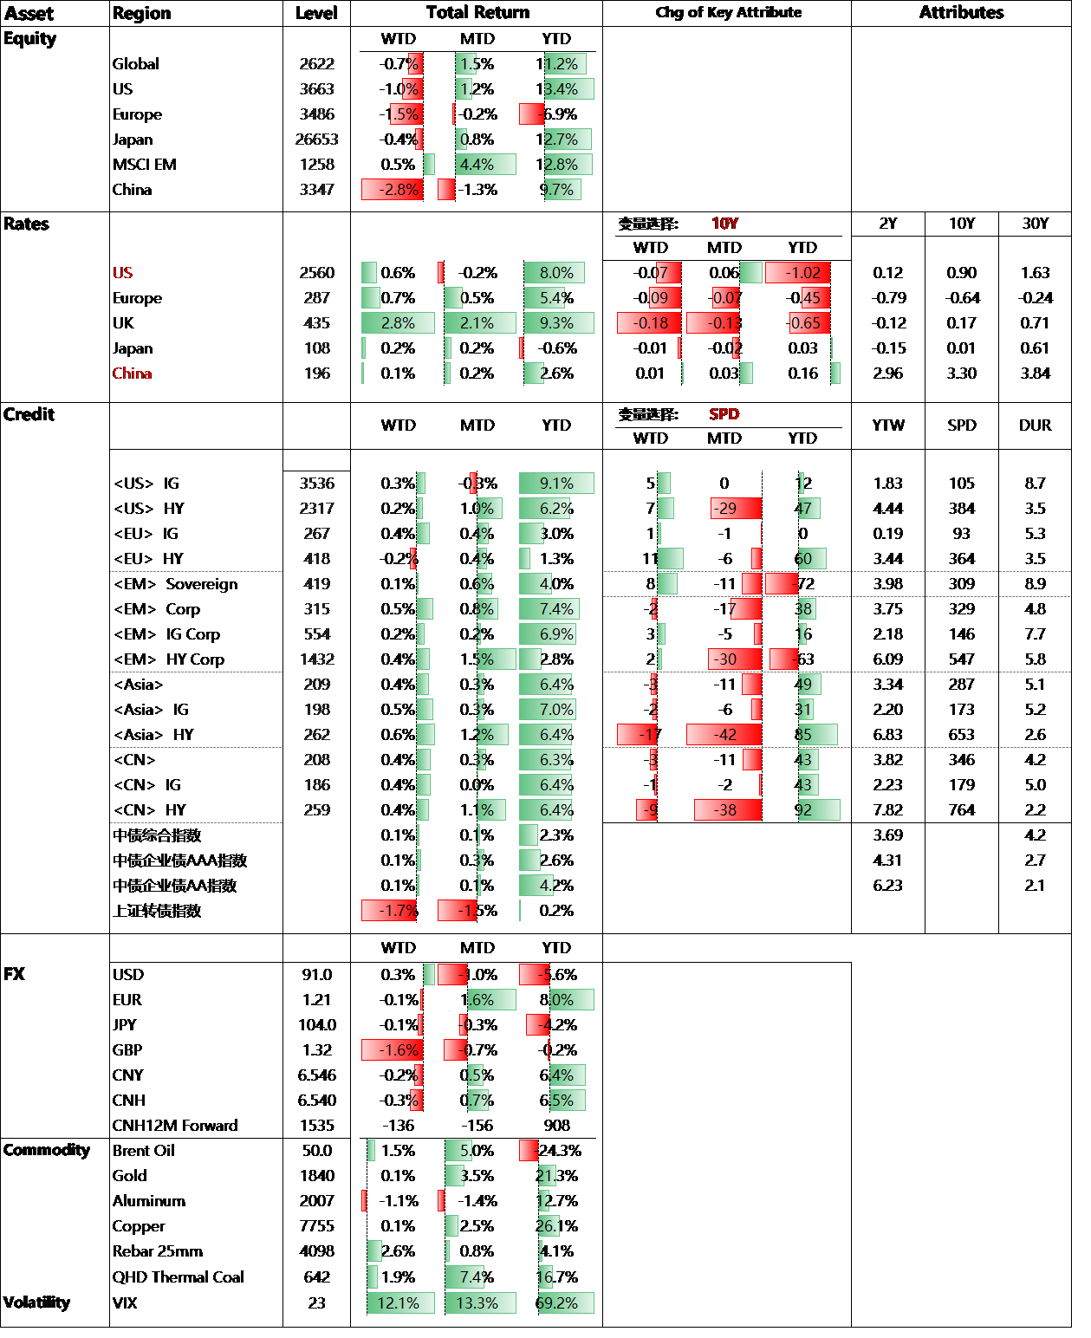

# 二.主要板块回顾

## 1.总体概览

### 1)Index Review

图2: Return & Valuation

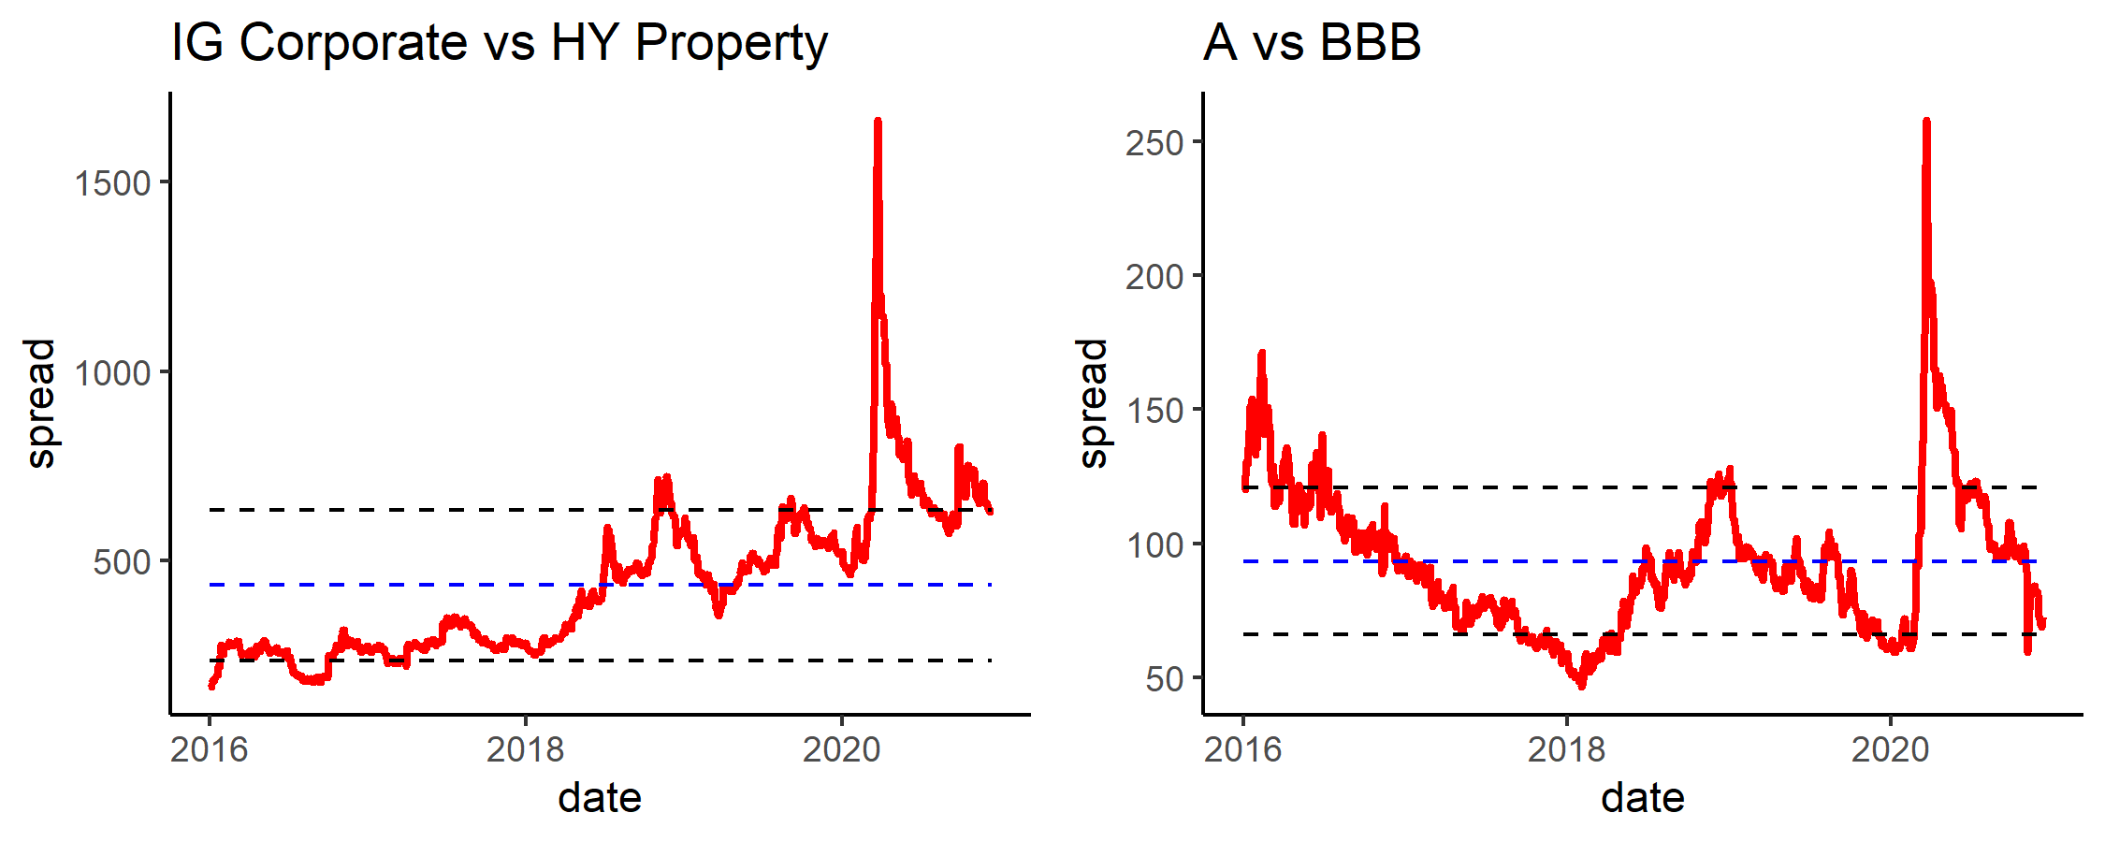

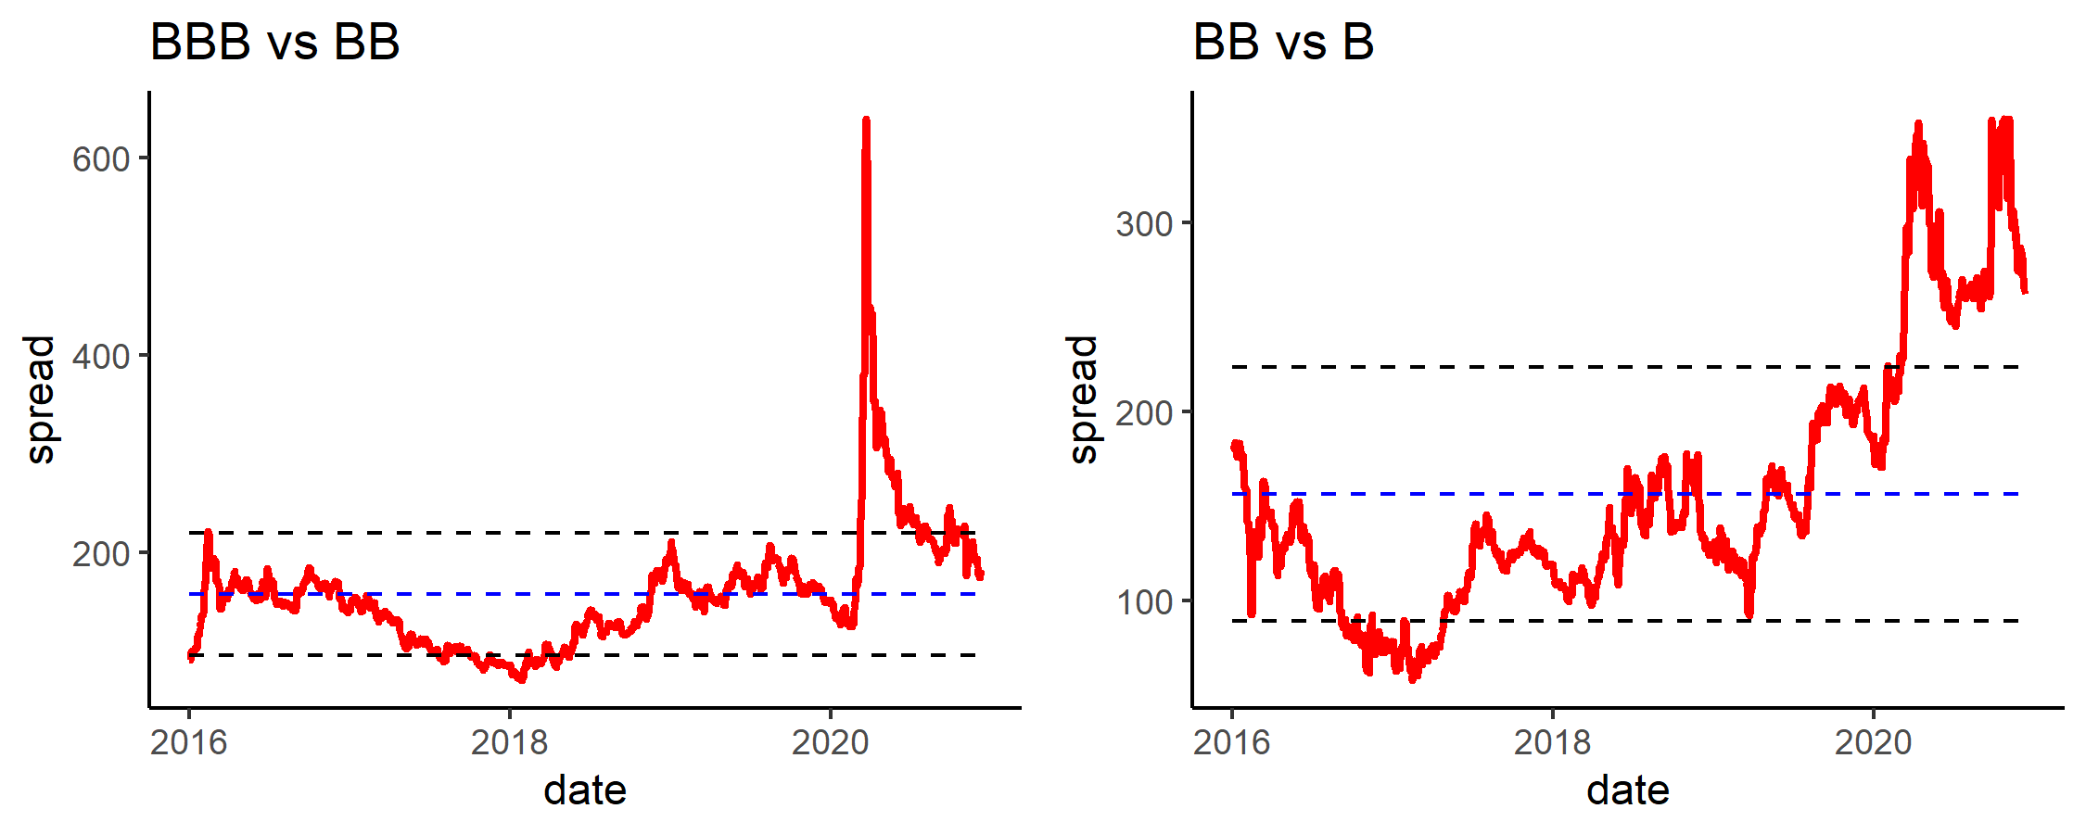

### 2)Market Summary

表1: Market Summary By Category

| Category | Amount | weight | issues | YTM | spread | duration | price_chg | price_MTD | price_YTD | spread_chg | spread_MTD | spread_YTD |
| --- | --- | --- | --- | --- | --- | --- | --- | --- | --- | --- | --- | --- |
| AT1 | 102,200 | 7.5% | 78 | 4.9 | 360 | 3.4 | -0.3% | 0.1% | -4.2% | 17 | 2 | 47 |
| EM | 656,127 | 50.5% | 490 | 3.2 | 230 | 8.1 | -0.0% | 0.6% | -3.7% | 4 | -12 | 29 |
| Financials | 122,915 | 8.8% | 201 | 1.7 | 139 | 3.4 | 0.3% | 0.1% | 2.4% | -4 | -10 | 16 |
| HY Property | 140,777 | 9.5% | 305 | 8.2 | 776 | 2.0 | 0.1% | 0.7% | -4.2% | -2 | -15 | 155 |
| IG Corporate | 209,155 | 15.5% | 303 | 2.0 | 145 | 5.5 | 0.5% | -0.2% | 2.7% | -1 | -1 | 29 |
| Industry | 16,152 | 1.1% | 39 | 6.4 | 602 | 1.8 | -0.0% | 0.3% | -7.8% | -1 | -49 | -42 |
| LGFV | 63,133 | 4.4% | 181 | 3.4 | 326 | 2.0 | 0.1% | 0.1% | 0.2% | -3 | -20 | 42 |
| Tier 2 | 36,600 | 2.8% | 29 | 2.2 | 154 | 5.9 | 0.2% | 0.4% | 2.9% | 2 | -15 | -23 |

表2: Market Summary By rating2

| rating2 | Amount | weight | issues | YTM | spread | duration | price_chg | price_MTD | price_YTD | spread_chg | spread_MTD | spread_YTD |
| --- | --- | --- | --- | --- | --- | --- | --- | --- | --- | --- | --- | --- |
| A | 341,073 | 25.7% | 384 | 1.9 | 119 | 6.8 | 0.4% | -0.1% | 4.1% | 0 | -2 | 17 |
| AA | 115,422 | 9.2% | 50 | 1.7 | 79 | 9.5 | -0.1% | -0.2% | 5.3% | 7 | -2 | 4 |
| B | 236,686 | 16.5% | 339 | 6.9 | 637 | 4.3 | 0.1% | 1.6% | -6.8% | -6 | -31 | 146 |
| BB | 199,469 | 14.4% | 256 | 4.6 | 375 | 4.4 | -0.2% | 0.8% | -3.6% | 12 | -20 | 62 |
| BBB | 391,354 | 29.9% | 495 | 2.7 | 192 | 6.1 | 0.1% | 0.1% | 1.1% | 4 | -9 | 28 |
| CCC | 21,197 | 1.2% | 19 | 9.8 | 902 | 5.2 | -0.3% | 2.3% | -72.8% | 9 | -75 | 396 |
| NR | 41,858 | 2.9% | 83 | 4.0 | 372 | 3.2 | 0.1% | 0.2% | -2.0% | -4 | -17 | -50 |

表3: Top 10

| Name | Rating | YTM | YTW | spread | duration | price_chg | spread_chg |
| --- | --- | --- | --- | --- | --- | --- | --- |
| TQLTHI 3.75 22 | CCC- | 20.6 | 20.6 | 2,052 | 1.7 | 45.8% | -2,270 |
| ANTOIL 7.5 22 | B+ | 19.3 | 19.3 | 1,918 | 1.7 | 9.3% | -504 |
| SINOPE 3.35 50 | A+ | 3.0 | 3.0 | 138 | 18.7 | 3.0% | -12 |
| BABA 4.2 47 | A+ | 2.7 | 2.7 | 110 | 17.2 | 3.0% | -4 |
| ELSALV 7.65 35 | B- | 8.5 | 8.5 | 764 | 8.1 | 3.0% | -31 |
| ELSALV 7.1246 50 | B- | 8.2 | 8.2 | 654 | 10.9 | 2.9% | -12 |
| ELSALV 7.625 41 | B- | 8.6 | 8.5 | 694 | 9.4 | 2.8% | -13 |
| CFELEC 5.75 42 | BBB | 4.4 | 4.4 | 282 | 12.7 | 2.7% | -8 |
| EXIMCH 4 47 | A+ | 2.6 | 2.6 | 95 | 17.7 | 2.7% | -3 |
| SINOPE 3.68 49 | A+ | 3.0 | 3.0 | 140 | 17.9 | 2.7% | -2 |

表4: Bottom 10

| Name | Rating | YTM | YTW | spread | duration | price_chg | spread_chg |
| --- | --- | --- | --- | --- | --- | --- | --- |
| CFELEC 5.15 47 | BBB | 5 | 4.8 | 395 | 8.9 | -8.0% | 99 |
| CHFOTN 6.9 23 | BB- | 15 | 15.3 | 1,513 | 1.8 | -5.5% | 325 |
| CHFOTN 8.6 24 | BB- | 14 | 13.8 | 1,340 | 2.7 | -5.0% | 192 |
| CHFOTN 8.05 25 | BB- | 14 | 13.7 | 1,337 | 3.1 | -4.1% | 142 |
| CHFOTN 9 21 | BB- | 18 | 17.7 | 1,706 | 0.6 | -3.7% | 641 |
| CHFOTN 8.75 22 | BB- | 14 | 14.0 | 1,389 | 1.6 | -3.6% | 250 |
| CHFOTN 6.92 22 | BB- | 14 | 13.8 | 1,362 | 1.3 | -2.4% | 203 |
| HKIQCL 5.95 25 | BBB | 5 | 5.0 | 465 | 3.6 | -1.9% | 56 |
| OMAN 6.75 48 | BB- | 7 | 7.0 | 535 | 11.8 | -1.8% | 28 |
| EAGRUY 7.5 25 | CCC | 11 | 11.0 | 1,061 | 3.5 | -1.8% | 63 |

表5: Top 10 MTD

| Name | Rating | YTM | YTW | spread | duration | price_chg | spread_chg |
| --- | --- | --- | --- | --- | --- | --- | --- |
| TQLTHI 3.75 22 | CCC- | 20.6 | 20.6 | 2,052 | 1.7 | 62.1% | -2,918 |
| ANTOIL 7.5 22 | B+ | 19.3 | 19.3 | 1,918 | 1.7 | 13.7% | -722 |
| ZAMBIN 8.97 27 | NR | 22.9 | 22.9 | 2,388 | 3.2 | 9.7% | -222 |
| COSTAR 7.158 45 | B | 7.6 | 7.6 | 601 | 10.9 | 8.4% | -79 |
| COSTAR 7 44 | B | 7.6 | 7.6 | 598 | 10.8 | 8.3% | -75 |
| COSTAR 5.625 43 | B | 6.8 | 6.8 | 520 | 11.8 | 7.8% | -67 |
| COSTAR 6.125 31 | B | 6.9 | 6.9 | 607 | 6.7 | 6.8% | -108 |
| ANGOL 9.125 49 | CCC+ | 10.1 | 10.0 | 842 | 9.4 | 6.4% | -68 |
| ANGOL 9.375 48 | CCC+ | 10.1 | 10.1 | 850 | 8.8 | 6.2% | -65 |
| ELSALV 7.1246 50 | B- | 8.2 | 8.2 | 654 | 10.9 | 6.0% | -55 |

表6: Bottom 10 MTD

| Name | Rating | YTM | YTW | spread | duration | price_chg | spread_chg |
| --- | --- | --- | --- | --- | --- | --- | --- |
| CNOOC 3.3 49 | A+ | 3.3 | 3.3 | 164 | 18.4 | -5.7% | 28 |
| CFELEC 5.15 47 | BBB | 5.0 | 4.8 | 395 | 8.9 | -5.0% | 53 |
| CNOOC 4.25 43 | A+ | 3.3 | 3.3 | 171 | 14.9 | -4.2% | 27 |
| CNOOC 7.5 39 | A+ | 3.3 | 3.3 | 172 | 11.6 | -3.7% | 28 |
| CNOOC 6.4 37 | A+ | 3.3 | 3.3 | 163 | 11.1 | -3.7% | 24 |
| CNOOC 5.875 35 | A+ | 3.0 | 3.0 | 214 | 10.2 | -3.6% | 33 |
| CNOOC 4.875 44 | A+ | 3.3 | 3.3 | 166 | 14.9 | -3.6% | 17 |
| SRILAN 6.825 26 | CCC+ | 19.1 | 19.1 | 1,870 | 3.9 | -3.5% | 102 |
| CNOOC 4.2 45 | A+ | 3.2 | 3.2 | 160 | 15.9 | -3.2% | 17 |
| CNOOC 5.75 41 | A+ | 3.2 | 3.2 | 162 | 13.0 | -3.2% | 20 |

表7: Top 10 YTD

| Name | Rating | YTM | YTW | spread | duration | price_chg | spread_chg |
| --- | --- | --- | --- | --- | --- | --- | --- |
| FANHAI 14.5 21 | NR | 29.4 | 29.4 | 2,924 | 0.35 | 41.5% | -734 |
| XINHUZ 11 22 | B- | 13.0 | 20.3 | 2,015 | 1.10 | 23.7% | -206 |
| XIN 14.2 21 | CCC+ | 20.7 | 20.7 | 2,057 | 0.72 | 22.7% | -25 |
| EAGRUY 7.5 25 | CCC | 11.0 | 11.0 | 1,061 | 3.54 | 21.8% | -108 |
| WSTP 5 46 | BBB+ | 2.5 | 2.5 | 89 | 16.12 | 21.8% | -36 |
| CBAAU 3.743 39 | BBB+ | 2.5 | 2.5 | 88 | 13.82 | 20.7% | -46 |
| WSTP 4.421 39 | BBB+ | 2.5 | 2.5 | 88 | 13.27 | 19.9% | -44 |
| XINHUZ 11 21 | B- | 11.7 | 17.6 | 1,704 | 0.89 | 19.8% | -261 |
| BABA 4.4 57 | A+ | 2.9 | 2.8 | 122 | 20.62 | 19.7% | -5 |
| CBAAU 4.316 48 | BBB+ | 2.9 | 2.9 | 126 | 16.99 | 19.2% | -16 |

表8: Bottom 10 YTD

| Name | Rating | YTM | YTW | spread | duration | price_chg | spread_chg |
| --- | --- | --- | --- | --- | --- | --- | --- |
| SRILAN 7.85 29 | CCC+ | 18 | 18 | 1,674 | 4.9 | -35.5% | 1,104 |
| SRILAN 7.55 30 | CCC+ | 16 | 16 | 1,558 | 5.3 | -34.3% | 984 |
| SRILAN 6.825 26 | CCC+ | 19 | 19 | 1,870 | 3.9 | -33.9% | 1,333 |
| SRILAN 6.75 28 | CCC+ | 17 | 17 | 1,601 | 4.9 | -33.2% | 1,054 |
| SRILAN 6.85 25 | CCC+ | 20 | 20 | 1,910 | 3.6 | -32.8% | 1,402 |
| SRILAN 6.2 27 | CCC+ | 17 | 17 | 1,647 | 4.5 | -32.5% | 1,114 |
| SRILAN 6.85 24 | CCC+ | 24 | 24 | 2,350 | 2.5 | -31.9% | 1,883 |
| SRILAN 6.125 25 | CCC+ | 19 | 19 | 1,904 | 3.5 | -31.0% | 1,402 |
| SRILAN 6.35 24 | CCC+ | 22 | 22 | 2,143 | 2.7 | -30.6% | 1,668 |
| SRILAN 5.75 23 | CCC+ | 25 | 25 | 2,523 | 1.9 | -27.3% | 2,087 |

### 3)Duration Matrix

表9: Duration Matrix for price_chg By Category

| level1 | X0.1 | X1.3 | X3.5 | X5.10 | X10. |
| --- | --- | --- | --- | --- | --- |
| AT1 |  | -0.2% | -0.1% | -0.2% |  |
| EM | 0.1% | 0.1% | 0.2% | 0.1% | -0.1% |
| Financials | 0.1% | 0.2% | 0.4% | 1.0% |  |
| HY Property | 0.1% | 0.3% | 0.5% |  |  |
| IG Corporate | 0.1% | 0.1% | 0.3% | 0.8% | 1.6% |
| LGFV | 0.2% | 0.2% |  |  |  |

表10: Duration Matrix for spread By Category

| level1 | X0.1 | X1.3 | X3.5 | X5.10 | X10. |
| --- | --- | --- | --- | --- | --- |
| AT1 |  | 366 | 380 | 361 |  |
| EM | 230 | 231 | 301 | 262 | 227 |
| Financials | 134 | 150 | 134 | 150 |  |
| HY Property | 731 | 845 | 694 |  |  |
| IG Corporate | 136 | 140 | 147 | 150 | 144 |
| LGFV | 245 | 403 |  |  |  |

## 2.HY Property

### 1)Index Review

图3: Return & Valuation

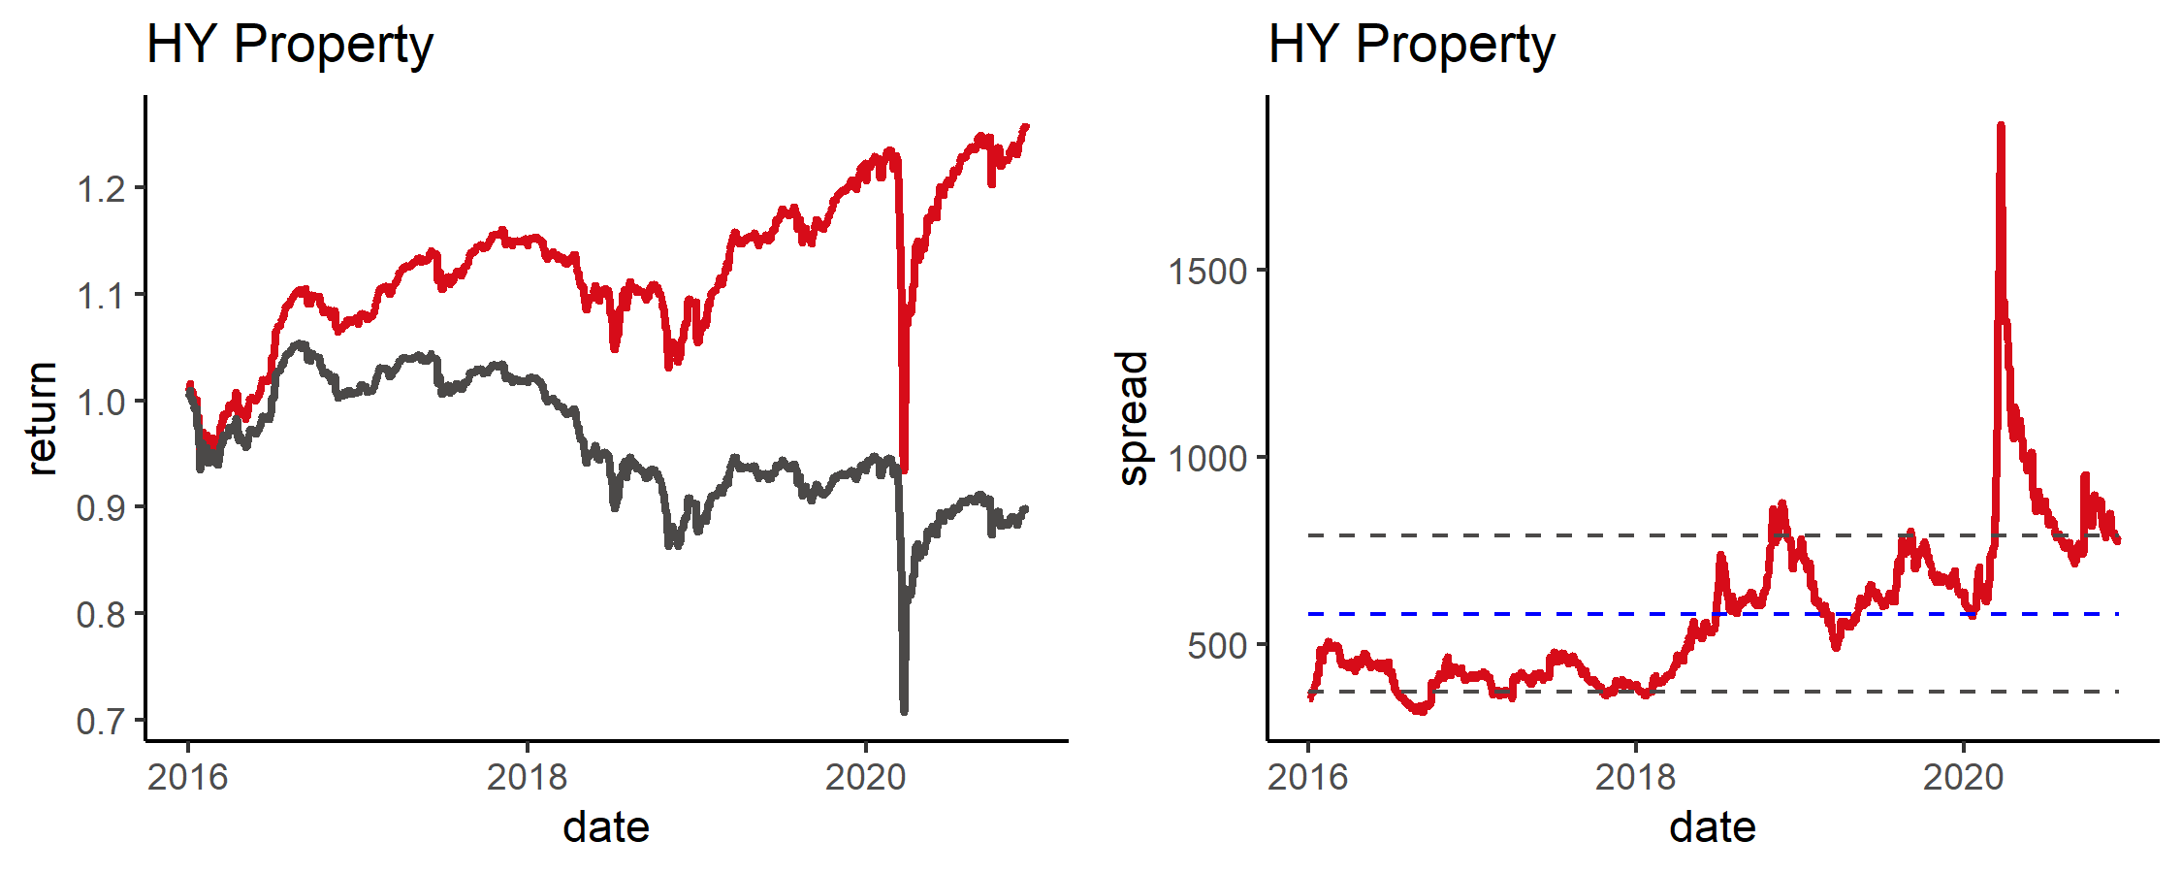

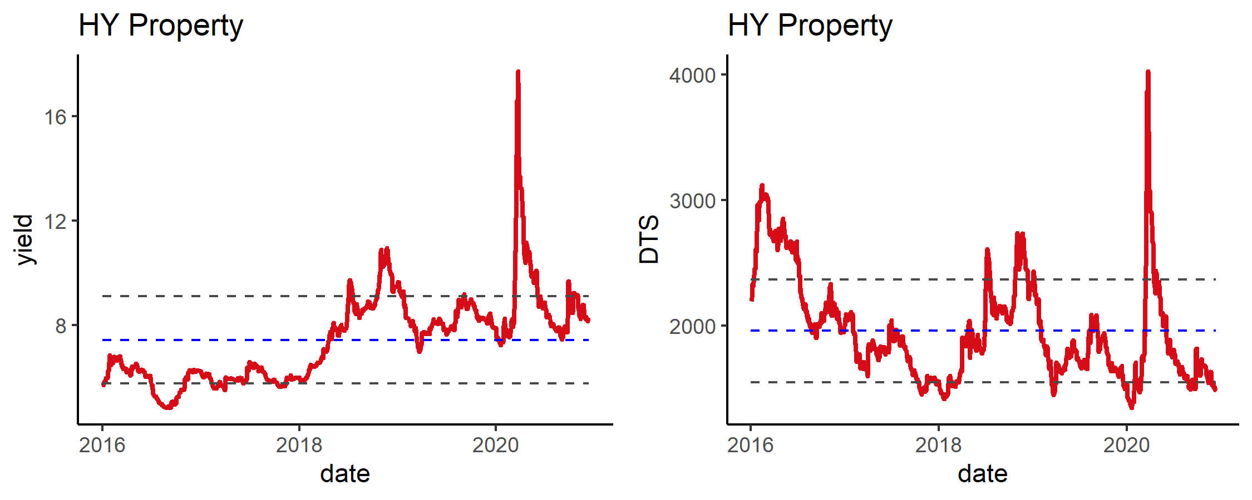

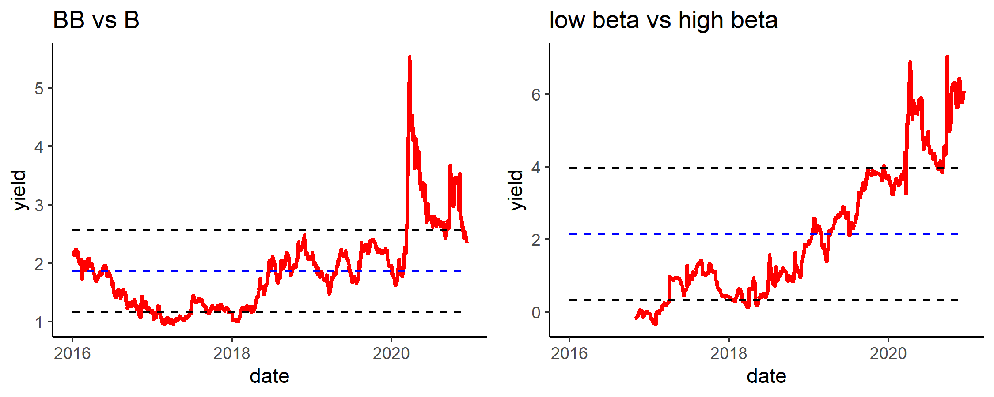

### 2)HY Property Summary

表11: Summary By rating2

| rating2 | Amount | weight | issues | YTM | spread | duration | price_chg | price_MTD | price_YTD | spread_chg | spread_MTD | spread_YTD |
| --- | --- | --- | --- | --- | --- | --- | --- | --- | --- | --- | --- | --- |
| B | 9,267,116 | 66.6% | 202 | 9.4 | 911 | 1.9 | 0.4% | 1.2% | 4.0% | -10 | -12 | 186 |
| BB | 3,190,810 | 22.9% | 77 | 6.2 | 559 | 2.0 | -0.1% | 0.6% | 3.4% | 25 | -33 | 150 |
| BBB | 1,110,555 | 8.0% | 17 | 3.9 | 276 | 2.4 | 0.2% | 0.4% | 7.8% | -6 | -40 | -49 |
| NR | 316,136 | 2.3% | 8 | 7.0 | 677 | 2.3 | 0.2% | 0.1% | -2.4% | 5 | -93 | -125 |

表12: Summary By Label

| Label | Amount | weight | issues | YTM | spread | duration | price_chg | price_MTD | price_YTD | spread_chg | spread_MTD | spread_YTD |
| --- | --- | --- | --- | --- | --- | --- | --- | --- | --- | --- | --- | --- |
| crossover | 1,597,614 | 11.5% | 23 | 4.4 | 320 | 2.7 | 0.2% | 0.4% | 8.7% | -5 | -35 | -53 |
| high beta | 7,295,337 | 52.4% | 159 | 33.6 | 3,366 | 6.2 | 0.5% | 1.6% | -35.0% | 34 | -93 | 330 |
| low beta | 5,020,811 | 36.1% | 123 | 4.0 | 339 | 1.8 | 0.3% | 0.7% | 5.8% | -17 | -48 | -10 |

表13: Top 10

| Name | Rating | YTM | YTW | spread | duration | price_chg | spread_chg |
| --- | --- | --- | --- | --- | --- | --- | --- |
| DALWAN 7.25 24 | BB | 6.7 | 6.7 | 635 | 2.7 | 2.2% | -68 |
| YUZHOU 7.375 26 | B+ | 6.1 | 6.1 | 583 | 4.1 | 1.8% | -36 |
| YUZHOU 7.85 26 | B+ | 6.7 | 6.7 | 632 | 4.4 | 1.4% | -23 |
| EVERRE 10.5 24 | B | 15.8 | 15.8 | 1,546 | 2.6 | 1.3% | -31 |
| TPHL 6.2 26 | B+ | 5.5 | 5.5 | 518 | 4.4 | 1.2% | -17 |
| PWRLNG 5.95 25 | B | 5.5 | 5.6 | 519 | 3.8 | 1.2% | -23 |
| CENCHI 7.75 24 | B+ | 7.3 | 7.3 | 693 | 3.0 | 1.1% | -27 |
| ZHPRHK 7.875 24 | B | 7.0 | 7.0 | 661 | 2.9 | 1.1% | -27 |
| CENCHI 7.65 23 | B+ | 6.5 | 6.5 | 633 | 2.3 | 1.1% | -34 |
| CIFIHG 5.25 26 | BB- | 4.4 | 4.4 | 401 | 4.7 | 1.1% | -17 |

表14: Bottom 10

| Name | Rating | YTM | YTW | spread | duration | price_chg | spread_chg |
| --- | --- | --- | --- | --- | --- | --- | --- |
| CHFOTN 6.9 23 | BB- | 15 | 15 | 1,513 | 1.77 | -5.5% | 325 |
| CHFOTN 8.6 24 | BB- | 14 | 14 | 1,340 | 2.69 | -5.0% | 192 |
| CHFOTN 8.05 25 | BB- | 14 | 14 | 1,337 | 3.15 | -4.1% | 142 |
| CHFOTN 9 21 | BB- | 18 | 18 | 1,706 | 0.60 | -3.7% | 641 |
| CHFOTN 8.75 22 | BB- | 14 | 14 | 1,389 | 1.56 | -3.6% | 250 |
| CHFOTN 6.92 22 | BB- | 14 | 14 | 1,362 | 1.31 | -2.4% | 203 |
| CHFOTN 7.125 22 | BB- | 13 | 13 | 1,309 | 1.19 | -1.3% | 134 |
| BEIPRO 5.95 23 | NR | 9 | 9 | 884 | 1.97 | -0.7% | 48 |
| TIANHL 11.5 22 | B | 17 | 17 | 1,641 | 1.52 | -0.3% | 40 |
| CHFOTN 9 21 | BB- | 10 | 10 | 1,034 | 0.49 | -0.2% | 88 |

表15: Top 10 MTD

| Name | Rating | YTM | YTW | spread | duration | price_chg | spread_chg |
| --- | --- | --- | --- | --- | --- | --- | --- |
| EVERRE 10.5 24 | B | 15.8 | 15.8 | 1,546 | 2.6 | 4.7% | -153 |
| SUNAC 6.5 25 | B+ | 5.8 | 5.9 | 549 | 3.5 | 3.3% | -86 |
| EVERRE 9.5 24 | B | 16.5 | 16.5 | 1,617 | 2.6 | 3.3% | -101 |
| SUNAC 7 25 | B+ | 6.2 | 6.2 | 583 | 3.8 | 3.2% | -76 |
| YUZHOU 7.375 26 | B+ | 6.1 | 6.1 | 583 | 4.1 | 3.2% | -66 |
| YUZHOU 7.85 26 | B+ | 6.7 | 6.7 | 632 | 4.4 | 3.2% | -66 |
| GRNLGR 5.875 24 | BB- | 9.2 | 9.2 | 884 | 3.0 | 3.0% | -85 |
| GRNLGR 7.25 25 | BB- | 9.3 | 9.3 | 890 | 3.4 | 3.0% | -76 |
| EVERRE 8.75 25 | B | 15.1 | 15.1 | 1,478 | 3.3 | 2.9% | -69 |
| TIANHL 13 22 | B | 16.6 | 16.5 | 1,643 | 1.6 | 2.9% | -143 |

表16: Bottom 10 MTD

| Name | Rating | YTM | YTW | spread | duration | price_chg | spread_chg |
| --- | --- | --- | --- | --- | --- | --- | --- |
| CHFOTN 9 21 | BB- | 17.7 | 17.7 | 1,706 | 0.60 | -2.6% | 477 |
| CHFOTN 8.6 24 | BB- | 13.8 | 13.8 | 1,340 | 2.69 | -2.2% | 89 |
| CHFOTN 6.9 23 | BB- | 15.3 | 15.3 | 1,513 | 1.77 | -2.2% | 149 |
| BEIPRO 5.95 23 | NR | 9.0 | 9.0 | 884 | 1.97 | -2.1% | 120 |
| CHFOTN 8.75 22 | BB- | 14.0 | 14.0 | 1,389 | 1.56 | -1.5% | 124 |
| CHFOTN 6.92 22 | BB- | 13.8 | 13.8 | 1,362 | 1.31 | -1.0% | 107 |
| CHFOTN 8.05 25 | BB- | 13.7 | 13.7 | 1,337 | 3.15 | -0.9% | 40 |
| XINHUZ 11 23 | B- | 14.0 | 16.1 | 1,606 | 1.90 | -0.3% | 83 |
| GZFYRE 13.5 21 | B- | 11.8 | 11.8 | 1,168 | 0.33 | 0.0% | 88 |
| SHIMAO 4.75 22 | BB | 3.2 | 2.5 | 414 | 1.47 | 0.0% | 182 |

表17: Top 10 YTD

| Name | Rating | YTM | YTW | spread | duration | price_chg | spread_chg |
| --- | --- | --- | --- | --- | --- | --- | --- |
| XINHUZ 11 22 | B- | 13.0 | 20.3 | 2,015 | 1.10 | 23.7% | -206 |
| XIN 14.2 21 | CCC+ | 20.7 | 20.7 | 2,057 | 0.72 | 22.7% | -25 |
| XINHUZ 11 21 | B- | 11.7 | 17.6 | 1,704 | 0.89 | 19.8% | -261 |
| DAFAPG 12.875 21 | B- | 12.3 | 12.3 | 1,216 | 0.51 | 18.9% | -338 |
| SUNCHN 11.5 21 | NR | 22.0 | 22.0 | 2,192 | 0.48 | 18.7% | 302 |
| JIAYUA 13.75 22 | B- | 11.3 | 11.5 | 1,114 | 1.09 | 18.5% | -510 |
| MOLAND 12.85 21 | B- | 9.6 | 9.6 | 950 | 0.80 | 18.1% | -364 |
| REDSUN 10.5 22 | B- | 6.9 | 6.7 | 654 | 1.61 | 16.5% | -260 |
| JNHUIG 11.75 21 | B- | 5.9 | 5.9 | 574 | 0.83 | 16.3% | -458 |
| JINGRU 12 22 | B- | 13.6 | 13.6 | 1,347 | 1.36 | 16.0% | 12 |

表18: Bottom 10 YTD

| Name | Rating | YTM | YTW | spread | duration | price_chg | spread_chg |
| --- | --- | --- | --- | --- | --- | --- | --- |
| GZRFPR 8.125 24 | B+ | 13.2 | 13.2 | 1,283 | 2.8 | -9.2% | 717 |
| CHFOTN 8.6 24 | BB- | 13.8 | 13.8 | 1,340 | 2.7 | -8.8% | 748 |
| GZRFPR 8.625 24 | B+ | 13.2 | 13.2 | 1,284 | 2.6 | -8.2% | 731 |
| GZRFPR 8.125 23 | B+ | 13.0 | 13.0 | 1,284 | 1.9 | -4.8% | 757 |
| GZRFPR 5.875 23 | B+ | 12.8 | 12.8 | 1,261 | 1.9 | -4.7% | 739 |
| GRNLGR 5.875 24 | BB- | 9.2 | 9.2 | 884 | 3.0 | -1.9% | 397 |
| CHFOTN 7.125 22 | BB- | 13.2 | 13.2 | 1,309 | 1.2 | -1.5% | 806 |
| GZRFPR 9.125 22 | B+ | 11.8 | 11.8 | 1,171 | 1.4 | -1.2% | 673 |
| GRNLGR 6.75 23 | BB- | 9.1 | 9.1 | 896 | 2.4 | -0.8% | 426 |
| EVERRE 9.5 24 | B | 16.5 | 16.5 | 1,617 | 2.6 | -0.4% | 585 |

### 3)Duration Matrix

表19: Duration Matrix for price_chg By Label

| level1 | 0~1 | 1~3 | 3~5 |
| --- | --- | --- | --- |
| crossover | 0.1% | 0.1% | 0.3% |
| high beta | 0.0% | 0.3% | 0.2% |
| low beta | 0.2% | 0.4% | 0.8% |

表20: Duration Matrix for YTM By Label

| level1 | 0~1 | 1~3 | 3~5 |
| --- | --- | --- | --- |
| crossover | 3.76 | 3.85 | 3.6 |
| high beta | 10.33 | 11.7 | 11.2 |
| low beta | 4.04 | 5.31 | 5.57 |

表21: Duration Matrix for price_chg By rating2

| level1 | 0~1 | 1~3 | 3~5 |
| --- | --- | --- | --- |
| BBB | 0.1% | 0.2% | 0.3% |
| BB | -0.4% | -0.2% | 0.3% |
| B | 0.2% | 0.4% | 0.7% |
| NR |  | -0.1% |  |

表22: Duration Matrix for YTM By rating2

| level1 | 0~1 | 1~3 | 3~5 |
| --- | --- | --- | --- |
| BBB | 4.23 | 3.97 | 3.59 |
| BB | 5.65 | 6.57 | 5.91 |
| B | 8.36 | 9.93 | 8.77 |
| NR |  | 7.13 |  |

## 3.IG Corporate

### 1)Index Review

图4: Return & Valuation

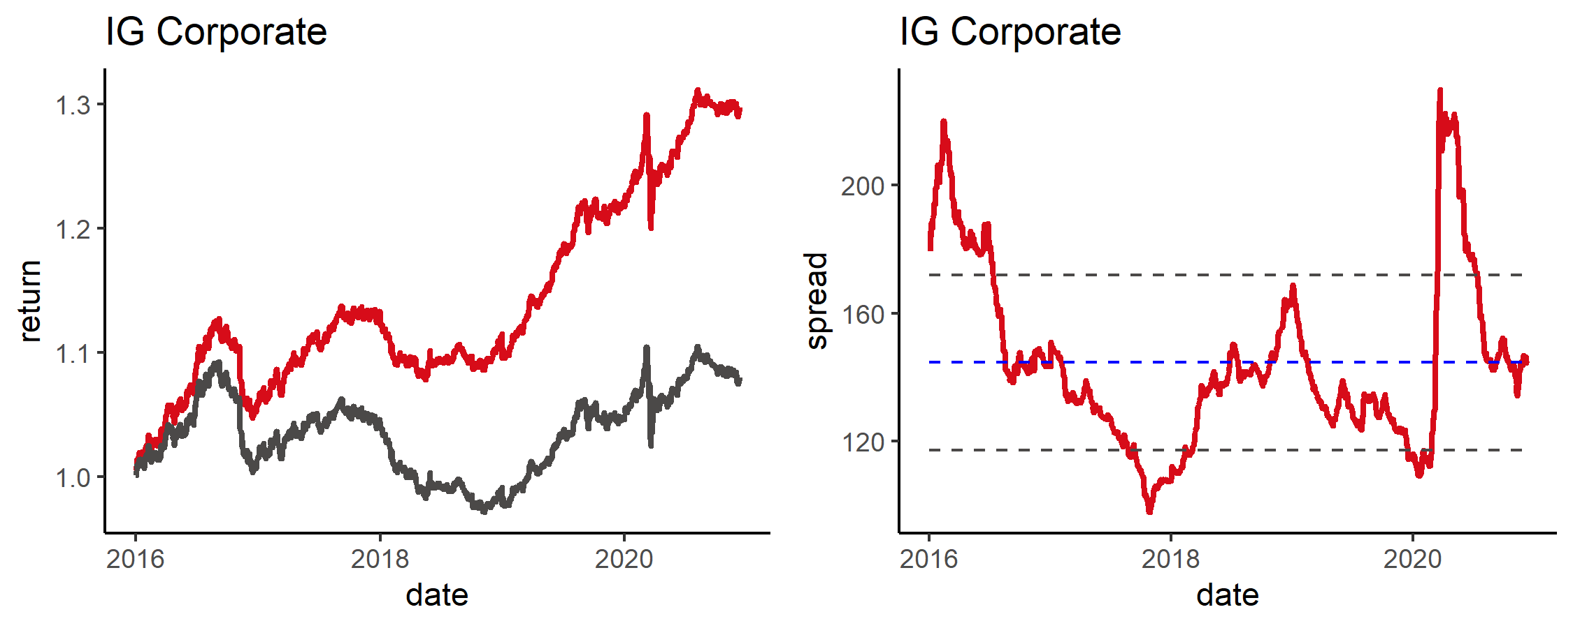

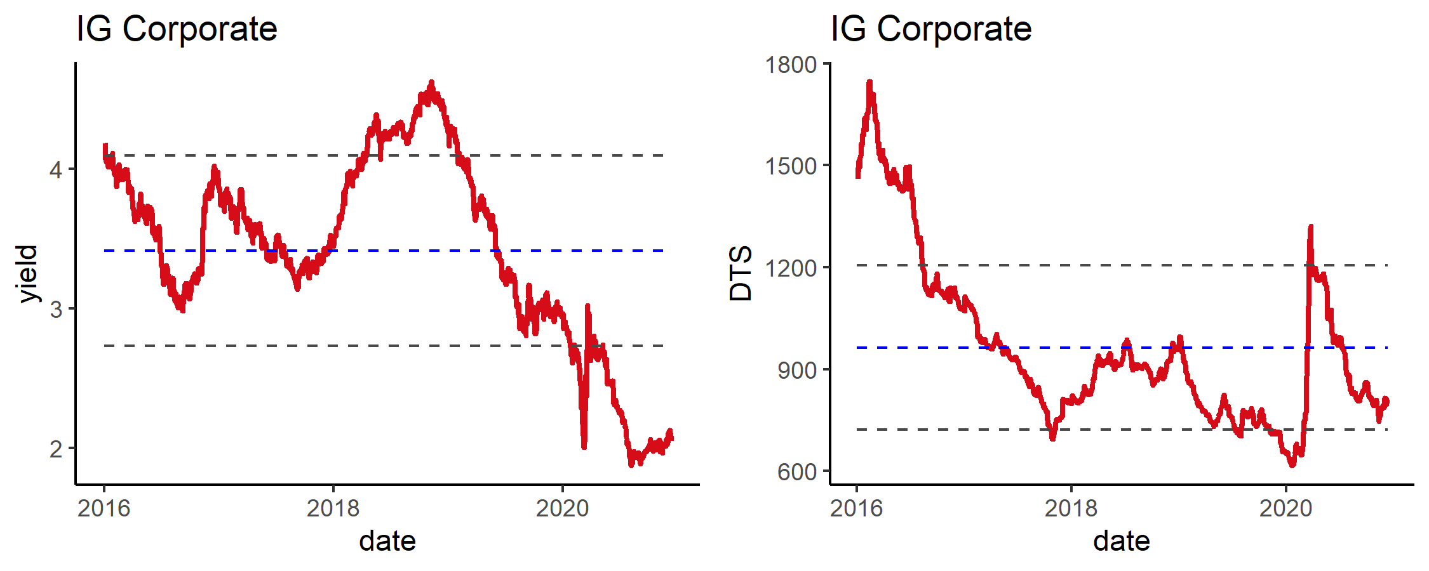

### 2)IG Corporate Summary

表23: Summary By rating2

| rating2 | Amount | weight | issues | YTM | spread | duration | price_chg | price_MTD | price_YTD | spread_chg | spread_MTD | spread_YTD |
| --- | --- | --- | --- | --- | --- | --- | --- | --- | --- | --- | --- | --- |
| A | 14,975,522 | 66.2% | 180 | 1.8 | 115 | 6.2 | 0.6% | -0.2% | 6.7% | -1 | 0 | 19 |
| BB | 62,674 | 0.3% | 2 | 6.1 | 602 | 1.2 | -0.1% | 0.1% | 4.0% | 16 | 8 | 202 |
| BBB | 6,785,628 | 30.0% | 110 | 2.4 | 193 | 4.2 | 0.5% | 0.1% | 5.5% | -2 | -5 | 45 |
| NR | 803,308 | 3.6% | 11 | 2.9 | 257 | 3.4 | 0.3% | 0.2% | 4.7% | -3 | -1 | 71 |

表24: Summary By Label

| Label | Amount | weight | issues | YTM | spread | duration | price_chg | price_MTD | price_YTD | spread_chg | spread_MTD | spread_YTD |
| --- | --- | --- | --- | --- | --- | --- | --- | --- | --- | --- | --- | --- |
| other | 2,138,229 | 9.4% | 44 | 2.9 | 275 | 1.4 | 0.1% | 0.1% | 4.0% | 2 | 0 | 87 |
| property | 2,574,919 | 11.4% | 45 | 5.3 | 499 | 2.6 | 0.1% | 0.0% | 4.5% | 10 | 23 | 149 |
| soe | 12,505,472 | 55.3% | 162 | 2.3 | 173 | 5.5 | 0.5% | -0.2% | 6.2% | -2 | -6 | 36 |
| tech | 5,408,511 | 23.9% | 52 | 2.8 | 221 | 5.3 | 0.5% | 0.2% | 6.2% | -1 | -15 | 65 |

表25: Top 10

| Name | Rating | YTM | YTW | spread | duration | price_chg | spread_chg |
| --- | --- | --- | --- | --- | --- | --- | --- |
| SINOPE 3.35 50 | A+ | 3.0 | 3.0 | 138 | 19 | 3.0% | -12 |
| BABA 4.2 47 | A+ | 2.7 | 2.7 | 110 | 17 | 3.0% | -4 |
| SINOPE 3.68 49 | A+ | 3.0 | 3.0 | 140 | 18 | 2.7% | -2 |
| TENCNT 3.29 60 | A+ | 3.1 | 3.1 | 146 | 22 | 2.6% | 0 |
| JD 4.125 50 | BBB | 3.5 | 3.5 | 190 | 17 | 2.6% | -3 |
| BABA 4.4 57 | A+ | 2.9 | 2.8 | 122 | 21 | 2.6% | 0 |
| SINOPE 3.44 49 | A+ | 3.0 | 3.0 | 142 | 18 | 2.6% | -2 |
| TENCNT 3.24 50 | A+ | 3.0 | 3.0 | 139 | 19 | 2.5% | -1 |
| SINOPE 4.6 48 | A+ | 3.0 | 3.0 | 142 | 17 | 2.4% | -2 |
| SINOPE 4.875 42 | A+ | 3.0 | 3.0 | 136 | 14 | 2.3% | -8 |

表26: Bottom 10

| Name | Rating | YTM | YTW | spread | duration | price_chg | spread_chg |
| --- | --- | --- | --- | --- | --- | --- | --- |
| CNOOC 5.875 35 | A+ | 3.03 | 3.03 | 214 | 10.21 | -1.5% | 23 |
| CNOOC 6.4 37 | A+ | 3.32 | 3.31 | 163 | 11.14 | -1.2% | 17 |
| NANHAI 2.9 22 | BBB | 2.80 | 2.60 | 248 | 0.49 | -0.2% | 56 |
| CNOOC 7.875 32 | A+ | 2.84 | 2.84 | 195 | 8.15 | -0.2% | 12 |
| BABA 3.125 21 | A+ | 0.89 | 0.42 | 31 | 0.95 | -0.1% | 11 |
| XINAOG 6 21 | BBB | 1.50 | 1.50 | 138 | 0.42 | 0.0% | 8 |
| SINOPE 3.9 22 | A+ | 1.00 | 1.00 | 88 | 1.40 | 0.0% | 3 |
| CHGRID 2.125 21 | A+ | 0.84 | 0.84 | 72 | 0.43 | 0.0% | 1 |
| SINOPE 2.75 21 | A+ | 0.90 | 0.90 | 78 | 0.39 | 0.0% | 0 |
| SINOPC 3.125 23 | A+ | 1.14 | 1.14 | 97 | 2.28 | 0.0% | -1 |

表27: Top 10 MTD

| Name | Rating | YTM | YTW | spread | duration | price_chg | spread_chg |
| --- | --- | --- | --- | --- | --- | --- | --- |
| LNGFOR 3.85 32 | BBB | 3.0 | 3.0 | 208 | 8.9 | 1.2% | -16 |
| CITLTD 3.875 27 | BBB+ | 2.2 | 2.2 | 128 | 5.5 | 0.8% | -19 |
| BABA 4 37 | A+ | 2.6 | 2.6 | 96 | 12.5 | 0.8% | -9 |
| BABA 4.2 47 | A+ | 2.7 | 2.7 | 110 | 17.2 | 0.7% | -7 |
| GLPCHI 4.974 24 | BBB- | 2.6 | 2.6 | 226 | 2.9 | 0.7% | -20 |
| GEELZ 3 25 | BBB- | 3.0 | 3.0 | 263 | 3.9 | 0.7% | -14 |
| TENCNT 3.925 38 | A+ | 2.8 | 2.8 | 113 | 12.3 | 0.6% | -9 |
| HAOHUA 2 25 | BBB | 2.9 | 2.9 | 254 | 4.5 | 0.6% | -14 |
| HAOHUA 3.375 24 | BBB | 3.0 | 3.0 | 265 | 3.2 | 0.6% | -15 |
| BIDU 1.72 26 | A- | 1.4 | 1.4 | 112 | 5.0 | 0.6% | -4 |

表28: Bottom 10 MTD

| Name | Rating | YTM | YTW | spread | duration | price_chg | spread_chg |
| --- | --- | --- | --- | --- | --- | --- | --- |
| CNOOC 3.3 49 | A+ | 3.3 | 3.3 | 164 | 18 | -5.7% | 28 |
| CNOOC 4.25 43 | A+ | 3.3 | 3.3 | 171 | 15 | -4.2% | 27 |
| CNOOC 7.5 39 | A+ | 3.3 | 3.3 | 172 | 12 | -3.7% | 28 |
| CNOOC 6.4 37 | A+ | 3.3 | 3.3 | 163 | 11 | -3.7% | 24 |
| CNOOC 5.875 35 | A+ | 3.0 | 3.0 | 214 | 10 | -3.6% | 33 |
| CNOOC 4.875 44 | A+ | 3.3 | 3.3 | 166 | 15 | -3.6% | 17 |
| CNOOC 4.2 45 | A+ | 3.2 | 3.2 | 160 | 16 | -3.2% | 17 |
| CNOOC 5.75 41 | A+ | 3.2 | 3.2 | 162 | 13 | -3.2% | 20 |
| CNOOC 5 42 | A+ | 3.2 | 3.2 | 161 | 14 | -3.0% | 18 |
| SINOPC 4.25 43 | A+ | 3.1 | 3.1 | 144 | 15 | -2.3% | 12 |

表29: Top 10 YTD

| Name | Rating | YTM | YTW | spread | duration | price_chg | spread_chg |
| --- | --- | --- | --- | --- | --- | --- | --- |
| BABA 4.4 57 | A+ | 2.9 | 2.8 | 122 | 20.6 | 19.7% | -5 |
| CITLTD 4.75 36 | BBB+ | 2.8 | 2.8 | 117 | 11.1 | 17.4% | -45 |
| BABA 4.2 47 | A+ | 2.7 | 2.7 | 110 | 17.2 | 16.9% | -3 |
| BABA 4 37 | A+ | 2.6 | 2.6 | 96 | 12.5 | 14.2% | -13 |
| BABA 4.5 34 | A+ | 2.4 | 2.3 | 145 | 10.5 | 13.0% | 7 |
| CHGRID 4 47 | A+ | 2.8 | 2.8 | 114 | 17.2 | 11.8% | 21 |
| SINOPE 3.68 49 | A+ | 3.0 | 3.0 | 140 | 17.9 | 11.5% | 26 |
| SINOPE 3.44 49 | A+ | 3.0 | 3.0 | 142 | 18.4 | 11.5% | 27 |
| TENCNT 4.525 49 | A+ | 3.1 | 3.0 | 140 | 17.1 | 11.3% | 24 |
| LNGFOR 3.95 29 | BBB | 2.8 | 2.8 | 193 | 7.4 | 11.2% | -2 |

表30: Bottom 10 YTD

| Name | Rating | YTM | YTW | spread | duration | price_chg | spread_chg |
| --- | --- | --- | --- | --- | --- | --- | --- |
| HAOHUA 5.125 28 | BBB | 3.65 | 3.65 | 276 | 6.03 | 1.2% | 132 |
| HAOHUA 3.875 29 | BBB | 3.62 | 3.62 | 271 | 7.09 | 1.4% | 122 |
| HAOHUA 4.125 27 | BBB | 3.51 | 3.51 | 262 | 5.67 | 2.0% | 118 |
| HAOHUA 3.375 24 | BBB | 3.00 | 3.00 | 265 | 3.25 | 2.4% | 141 |
| HAOHUA 3.5 22 | BBB | 2.83 | 2.83 | 271 | 1.53 | 2.5% | 152 |
| HAOHUA 3.125 22 | BBB | 2.81 | 2.81 | 269 | 1.45 | 2.5% | 151 |
| HAOHUA 4.625 23 | BBB | 2.88 | 2.88 | 272 | 2.12 | 2.6% | 145 |
| SINOPE 2.75 21 | A+ | 0.90 | 0.90 | 78 | 0.39 | 2.7% | 6 |
| CNPCCH 4.5 21 | A | 0.93 | 0.93 | 81 | 0.38 | 2.7% | 4 |
| CHGRID 2.125 21 | A+ | 0.84 | 0.84 | 72 | 0.43 | 2.7% | 6 |

### 3)Duration Matrix

表31: Duration Matrix for spread_chg By Label

| level1 | X0.1 | X1.3 | X3.5 | X5.10 | X10. |
| --- | --- | --- | --- | --- | --- |
| other | 6 | -1 | -2 | -2 |  |
| property |  | -1 | -2 | -3 |  |
| soe | -3 | 0 | -1 | -2 | 2 |
| tech |  | -4 | -4 | -3 | -3 |

表32: Duration Matrix for spread By Label

| level1 | X0.1 | X1.3 | X3.5 | X5.10 | X10. |
| --- | --- | --- | --- | --- | --- |
| other | 201 | 177 | 148 | 161 |  |
| property |  | 171 | 209 | 200 |  |
| soe | 118 | 123 | 137 | 148 | 151 |
| tech |  | 113 | 141 | 121 | 126 |

表33: Duration Matrix for spread_chg By rating2

| level1 | X0.1 | X1.3 | X3.5 | X5.10 | X10. |
| --- | --- | --- | --- | --- | --- |
| A | 1 | -1 | -2 | -2 | 0 |
| BBB | -1 | -2 | -3 | -3 |  |
| NR |  | -1 | -1 |  |  |

表34: Duration Matrix for spread By rating2

| level1 | X0.1 | X1.3 | X3.5 | X5.10 | X10. |
| --- | --- | --- | --- | --- | --- |
| A | 94 | 103 | 108 | 119 | 141 |
| BBB | 172 | 185 | 194 | 204 |  |
| NR |  | 237 | 259 |  |  |

## 4.Financials

### 1)Index Review

图5: Return & Valuation

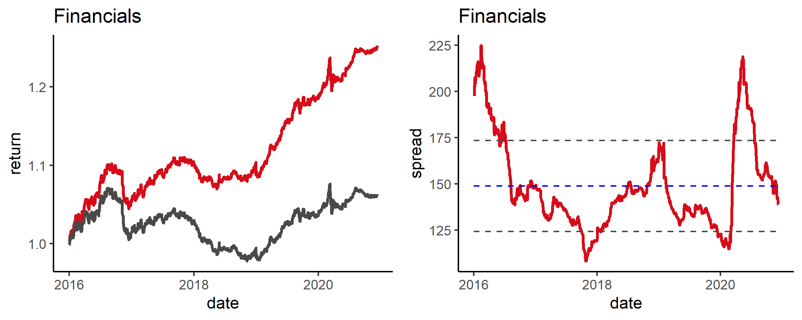

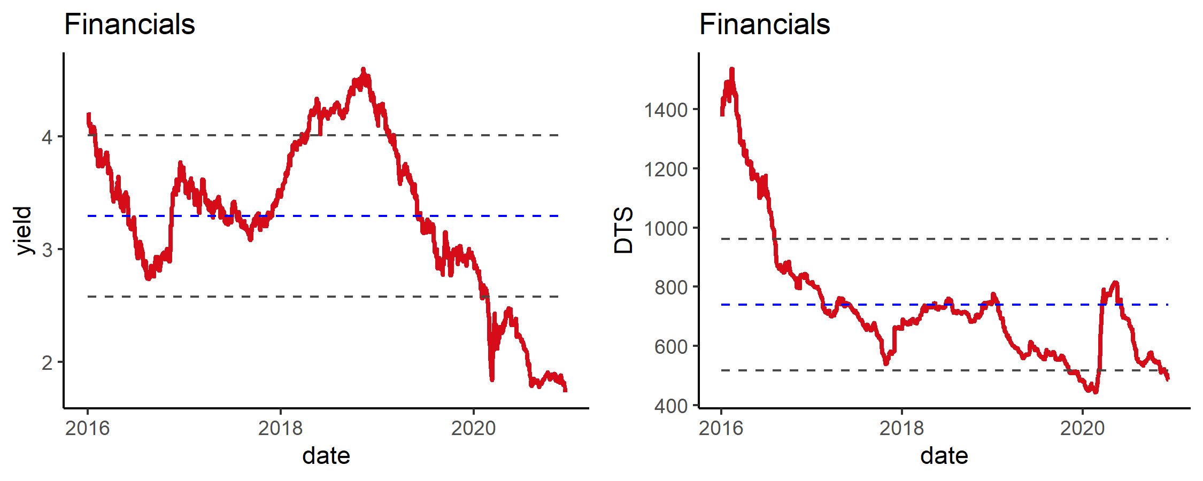

### 2)Financials Summary

表35: Summary By rating2

| rating2 | Amount | weight | issues | YTM | spread | duration | price_chg | price_MTD | price_YTD | spread_chg | spread_MTD | spread_YTD |
| --- | --- | --- | --- | --- | --- | --- | --- | --- | --- | --- | --- | --- |
| A | 8,449,641 | 65.9% | 127 | 1.5 | 110 | 3.4 | 0.4% | 0.2% | 5.7% | -3 | -4 | 10 |
| BB | 72,233 | 0.6% | 2 | 11.2 | 1,429 | 1.0 | 0.3% | 0.4% | 4.9% | -23 | 7 | 699 |
| BBB | 4,116,287 | 32.1% | 70 | 2.1 | 172 | 3.6 | 0.4% | 0.4% | 5.3% | -4 | -23 | 20 |
| NR | 182,366 | 1.4% | 2 | 2.2 | 208 | 1.4 | 0.2% | 0.2% | 4.7% | -9 | -11 | 42 |

表36: Summary By Label

| Label | Amount | weight | issues | YTM | spread | duration | price_chg | price_MTD | price_YTD | spread_chg | spread_MTD | spread_YTD |
| --- | --- | --- | --- | --- | --- | --- | --- | --- | --- | --- | --- | --- |
| AMC | 3,526,801 | 27.5% | 49 | 1.55 | 118 | 3.17 | 0.4% | 0.3% | 4.5% | -4 | -3 | 12 |
| big6 | 2,165,165 | 16.9% | 35 | 0.31 | 24 | 0.71 | 0.1% | 0.0% | 1.1% | -1 | -1 | 4 |
| insurance | 601,740 | 4.7% | 10 | 7.88 | 771 | 1.63 | 0.2% | 0.2% | 8.7% | 3 | 18 | 145 |
| JCBC | 287,356 | 2.2% | 7 | 0.06 | 5 | 0.11 | 0.0% | 0.0% | 0.2% | 0 | -2 | -2 |
| leasing | 2,910,932 | 22.7% | 45 | 0.71 | 59 | 1.14 | 0.1% | 0.1% | 2.0% | -2 | -2 | 11 |
| other | 1,195,694 | 9.3% | 25 | 5.42 | 848 | 1.13 | 0.3% | 0.4% | 1.9% | -37 | -40 | 536 |
| policy | 1,668,639 | 13.0% | 20 | 0.22 | 13 | 0.85 | 0.1% | 0.0% | 1.4% | 0 | 0 | -4 |
| security | 464,199 | 3.6% | 10 | 0.84 | 80 | 0.65 | 0.0% | 0.0% | 0.7% | 1 | 0 | 67 |

表37: Top 10

| Name | Rating | YTM | YTW | spread | duration | price_chg | spread_chg |
| --- | --- | --- | --- | --- | --- | --- | --- |
| EXIMCH 4 47 | A+ | 2.6 | 2.6 | 95 | 17.7 | 2.7% | -3 |
| HRINTH 4.95 47 | BBB+ | 4.2 | 4.2 | 255 | 15.4 | 2.4% | -3 |
| BOCAVI 2.625 30 | A- | 2.6 | 2.6 | 166 | 8.3 | 1.9% | -16 |
| ORIEAS 2.75 30 | BBB+ | 2.5 | 2.5 | 162 | 8.4 | 1.8% | -12 |
| BOCAVI 3 29 | A- | 2.5 | 2.5 | 163 | 7.4 | 1.6% | -16 |
| CCAMCL 4.75 29 | A- | 2.4 | 2.4 | 156 | 6.8 | 1.5% | -11 |
| EXIMCH 3.25 27 | A+ | 1.6 | 1.6 | 81 | 6.3 | 1.5% | -10 |
| ORIEAS 4.5 29 | BBB+ | 2.5 | 2.5 | 161 | 7.0 | 1.4% | -10 |
| GRWALL 2.375 30 | BBB+ | 2.5 | 2.5 | 164 | 8.5 | 1.3% | -7 |
| EXIMCH 3.375 27 | A+ | 1.6 | 1.6 | 71 | 5.6 | 1.3% | -14 |

表38: Bottom 10

| Name | Rating | YTM | YTW | spread | duration | price_chg | spread_chg |
| --- | --- | --- | --- | --- | --- | --- | --- |
| SDBC 2.625 22 | A+ | 0.72 | 0.72 | 60 | 1.09 | -0.0% | 5 |
| CINDBK 1.578 21 | BBB | 1.33 | 1.33 | 120 | 0.78 | 0.0% | 6 |
| CINDBK 1.54788 21 | BBB | 1.25 | 1.25 | 112 | 0.52 | 0.0% | 7 |
| CCBL 2.75 21 | A | 1.45 | 1.45 | 133 | 0.47 | 0.0% | 5 |
| SDBC 2.125 21 | A+ | 0.62 | 0.62 | 51 | 0.47 | 0.0% | 1 |
| EXIMCH 2 21 | A+ | 0.61 | 0.61 | 49 | 0.37 | 0.0% | -2 |
| CITICS 4.25 21 | BBB+ | 1.34 | 1.34 | 122 | 0.98 | 0.0% | 2 |
| ORIEAS 2.375 21 | BBB+ | 1.39 | 1.39 | 127 | 0.71 | 0.0% | 2 |
| CCB 2.25 21 | A | 0.94 | 0.94 | 82 | 0.85 | 0.0% | 0 |
| ABCIHL 3.875 21 | A | 1.08 | 1.08 | 96 | 0.76 | 0.0% | 1 |

表39: Top 10 MTD

| Name | Rating | YTM | YTW | spread | duration | price_chg | spread_chg |
| --- | --- | --- | --- | --- | --- | --- | --- |
| HRINTH 4.95 47 | BBB+ | 4.2 | 4.2 | 255 | 15.4 | 1.8% | -15 |
| BOCAVI 2.625 30 | A- | 2.6 | 2.6 | 166 | 8.3 | 1.3% | -19 |
| ORIEAS 2.75 30 | BBB+ | 2.5 | 2.5 | 162 | 8.4 | 1.3% | -19 |
| BOCAVI 3 29 | A- | 2.5 | 2.5 | 163 | 7.4 | 1.2% | -20 |
| ORIEAS 3.5 29 | BBB+ | 2.5 | 2.5 | 162 | 7.3 | 1.2% | -18 |
| ORIEAS 4.5 29 | BBB+ | 2.5 | 2.5 | 161 | 7.0 | 1.1% | -16 |
| CCAMCL 4.75 29 | A- | 2.4 | 2.4 | 156 | 6.8 | 1.0% | -16 |
| HRINTH 4.25 27 | BBB+ | 2.8 | 2.7 | 183 | 6.0 | 0.9% | -21 |
| CCAMCL 3.125 30 | A- | 2.5 | 2.5 | 163 | 7.8 | 0.8% | -13 |
| HRINTH 4.5 29 | BBB+ | 3.0 | 3.0 | 210 | 7.1 | 0.8% | -14 |

表40: Bottom 10 MTD

| Name | Rating | YTM | YTW | spread | duration | price_chg | spread_chg |
| --- | --- | --- | --- | --- | --- | --- | --- |
| CCAMCL 4.75 37 | A- | 3.6 | 3.6 | 195 | 12.0 | -0.5% | -3 |
| SDBC 4 37 | A+ | 2.6 | 2.6 | 99 | 12.1 | -0.4% | 0 |
| SDBC 1.625 30 | A+ | 1.7 | 1.7 | 77 | 9.1 | -0.2% | -2 |
| ICBCAS 3.538 27 | A | 1.9 | 1.9 | 105 | 6.2 | -0.2% | 0 |
| BCHINA 2.25 30 | A | 2.2 | 2.2 | 136 | 8.8 | -0.2% | -1 |
| SDIC 3.625 27 | A | 1.9 | 1.9 | 102 | 5.7 | -0.1% | -2 |
| SUNSHG 4.5 26 | BBB | 4.4 | 4.4 | 408 | 4.7 | -0.1% | 6 |
| BCHINA 3.5 27 | A | 2.0 | 2.0 | 110 | 5.7 | -0.1% | -2 |
| CDBALF 3.5 27 | A+ | 2.3 | 2.3 | 137 | 6.1 | -0.1% | -2 |
| BCHINA 3.625 29 | A | 2.1 | 2.1 | 122 | 7.2 | -0.0% | -3 |

表41: Top 10 YTD

| Name | Rating | YTM | YTW | spread | duration | price_chg | spread_chg |
| --- | --- | --- | --- | --- | --- | --- | --- |
| EXIMCH 4 47 | A+ | 2.6 | 2.6 | 95 | 17.7 | 15.5% | 3 |
| HRINTH 4.95 47 | BBB+ | 4.2 | 4.2 | 255 | 15.4 | 13.8% | 12 |
| CCAMCL 4.75 37 | A- | 3.6 | 3.6 | 195 | 12.0 | 13.3% | -6 |
| SDBC 3 26 | A+ | 1.0 | 1.0 | 68 | 5.1 | 10.6% | -25 |
| EXIMCH 2.875 26 | A+ | 1.1 | 1.1 | 70 | 5.0 | 10.3% | -22 |
| EXIMCH 3.8 25 | A+ | 1.1 | 1.1 | 75 | 4.4 | 10.3% | -41 |
| ORIEAS 3.5 29 | BBB+ | 2.5 | 2.5 | 162 | 7.3 | 10.2% | 7 |
| ORIEAS 4.5 29 | BBB+ | 2.5 | 2.5 | 161 | 7.0 | 9.7% | 7 |
| SDIC 3.75 29 | A | 2.1 | 2.1 | 118 | 7.3 | 9.6% | 8 |
| BCHINA 3.625 29 | A | 2.1 | 2.1 | 122 | 7.2 | 9.6% | 8 |

表42: Bottom 10 YTD

| Name | Rating | YTM | YTW | spread | duration | price_chg | spread_chg |
| --- | --- | --- | --- | --- | --- | --- | --- |
| EXIMCH 2 21 | A+ | 0.61 | 0.61 | 49 | 0.37 | 2.6% | -11 |
| SDBC 2.125 21 | A+ | 0.62 | 0.62 | 51 | 0.47 | 2.8% | -9 |
| ICBCAS 2.635 21 | A | 0.94 | 0.94 | 82 | 0.46 | 2.9% | 2 |
| ZHNBND 7.6 22 | BB- | 10.54 | 17.05 | 1,693 | 1.31 | 2.9% | 1,126 |
| ICBCAS 2.5 21 | A | 0.92 | 0.92 | 80 | 0.50 | 2.9% | 2 |
| BCHINA 2.25 21 | A | 0.88 | 0.88 | 76 | 0.58 | 3.0% | 3 |
| AGRBK 2.5 21 | A | 0.98 | 0.98 | 86 | 0.52 | 3.0% | 1 |
| ICBCIL 2.75 21 | A | 1.24 | 1.24 | 112 | 0.43 | 3.1% | 5 |
| HRINTH 3.25 21 | BBB+ | 1.77 | 1.77 | 165 | 0.47 | 3.1% | 41 |
| CCBL 2.75 21 | A | 1.45 | 1.45 | 133 | 0.47 | 3.2% | 12 |

### 3)Duration Matrix

表43: Duration Matrix for spread_chg By Label

| level1 | X0.1 | X1.3 | X3.5 | X5.10 | X10. |
| --- | --- | --- | --- | --- | --- |
| AMC | -2 | -3 | -6 | -7 | -2 |
| big6 | -3 | -2 | -4 | 0 |  |
| insurance |  | -8 |  |  |  |
| leasing | -2 | -5 | -3 | -9 |  |
| other | -1 | -5 | -3 |  |  |
| policy | 0 | 0 | 0 | -8 | -1 |
| security |  | -2 |  |  |  |

表44: Duration Matrix for spread By Label

| level1 | X0.1 | X1.3 | X3.5 | X5.10 | X10. |
| --- | --- | --- | --- | --- | --- |
| AMC | 151 | 137 | 159 | 174 | 229 |
| big6 | 80 | 85 | 101 | 118 |  |
| insurance |  | 200 |  |  |  |
| leasing | 129 | 141 | 152 | 162 |  |
| other | 117 | 234 | 133 |  |  |
| policy | 50 | 67 | 67 | 71 | 97 |
| security |  | 158 |  |  |  |

表45: Duration Matrix for spread_chg By rating2

| level1 | X0.1 | X1.3 | X3.5 | X5.10 | X10. |
| --- | --- | --- | --- | --- | --- |
| A | -2 | -2 | -3 | -7 | -1 |
| BBB | -3 | -3 | -4 | -7 |  |
| NR |  | -9 |  |  |  |

表46: Duration Matrix for spread By rating2

| level1 | X0.1 | X1.3 | X3.5 | X5.10 | X10. |
| --- | --- | --- | --- | --- | --- |
| A | 90 | 106 | 115 | 125 | 125 |
| BBB | 154 | 163 | 179 | 184 |  |
| NR |  | 208 |  |  |  |

## 5.LGFV

### 1)Index Review

图6: Return & Valuation





### 2)LGFV Summary

表47: Summary By rating2

| rating2 | Amount | weight | issues | YTM | spread | duration | price_chg | price_MTD | price_YTD | spread_chg | spread_MTD | spread_YTD |
| --- | --- | --- | --- | --- | --- | --- | --- | --- | --- | --- | --- | --- |
| A | 840,991 | 13.1% | 20 | 1.9 | 167 | 2.7 | 0.2% | 0.1% | 5.0% | 2 | -2 | 17 |
| BB | 655,190 | 10.2% | 18 | 5.4 | 528 | 1.6 | 0.2% | 0.4% | 6.7% | -6 | -20 | 68 |
| BBB | 3,704,259 | 57.5% | 102 | 3.3 | 309 | 2.0 | 0.2% | 0.2% | 4.4% | -2 | -23 | 67 |
| NR | 1,236,448 | 19.2% | 41 | 3.9 | 377 | 1.6 | 0.3% | 0.4% | 5.5% | -9 | -21 | -15 |

表48: Summary of price_chg By rating2

| level1 | X0.1 | X1.3 | X3.5 | X10. |
| --- | --- | --- | --- | --- |
| A | 0.0% | 0.1% | 0.2% |  |
| BBB | 0.1% | 0.2% | 0.0% | 1.8% |
| BB | 0.3% | 0.2% |  |  |
| NR | 0.4% | 0.2% |  |  |

表49: Summary of YTM By rating2

| level1 | X0.1 | X1.3 | X3.5 | X10. |
| --- | --- | --- | --- | --- |
| A | 1.65 | 1.58 | 2.28 |  |
| BBB | 2.56 | 3.7 | 3.63 | 3.64 |
| BB | 4.89 | 5.46 |  |  |
| NR | 2.78 | 4.25 |  |  |

表50: Top 10

| Name | Rating | YTM | YTW | spread | duration | price_chg | spread_chg |
| --- | --- | --- | --- | --- | --- | --- | --- |
| BEIENT 4.99 40 | BBB+ | 3.7 | 3.7 | 208 | 12.97 | 1.9% | -2 |
| BEIENT 6.375 41 | BBB+ | 3.6 | 3.6 | 199 | 12.79 | 1.7% | -1 |
| YUNINV 6.25 22 | BBB | 7.6 | 7.6 | 750 | 1.14 | 1.6% | -119 |
| WUECDE 5.8 21 | NR | 1.6 | 1.6 | 148 | 0.99 | 1.2% | -114 |
| YUNAEN 6.25 21 | BBB | 5.8 | 5.8 | 572 | 0.92 | 1.2% | -112 |
| BJEHF 4.95 23 | NR | 3.8 | 3.8 | 361 | 2.23 | 0.9% | -32 |
| GUAMET 2.31 30 | A | 2.6 | 2.6 | 174 | 8.62 | 0.9% | -2 |
| ZZTRAN 6.5 22 | BB+ | 4.4 | 4.4 | 431 | 1.41 | 0.8% | -47 |
| PDSOAM 5.75 23 | NR | 2.8 | 2.8 | 260 | 2.21 | 0.7% | -25 |
| HZLJDV 5.3 22 | NR | 3.4 | 3.4 | 355 | 1.87 | 0.7% | -16 |

表51: Bottom 10

| Name | Rating | YTM | YTW | spread | duration | price_chg | spread_chg |
| --- | --- | --- | --- | --- | --- | --- | --- |
| HKIQCL 5.95 25 | BBB | 5.0 | 5.0 | 465 | 3.60 | -1.9% | 56 |
| BAORON 6.25 21 | BBB | 5.2 | 5.2 | 508 | 0.94 | -0.5% | 69 |
| TYLCDI 3.7 23 | BBB- | 3.4 | 3.4 | 321 | 2.37 | -0.1% | 14 |
| GXCMIN 2.95 25 | BBB | 3.3 | 3.3 | 295 | 4.49 | -0.1% | 9 |
| SZIHOG 3.95 21 | A | 1.6 | 1.6 | 153 | 0.78 | -0.1% | 15 |
| SHRIHG 4.3 23 | BBB- | 3.4 | 3.4 | 319 | 1.96 | -0.1% | 11 |
| JXWCIG 3.4 22 | BBB | 2.8 | 2.8 | 265 | 1.90 | -0.0% | 8 |
| JNJKOS 3.15 21 | BBB | 2.4 | 2.4 | 229 | 0.86 | -0.0% | 13 |
| DLDETA 5.95 22 | BBB- | 6.0 | 6.0 | 589 | 1.50 | -0.0% | 13 |
| WHGBIO 2.9 25 | BBB- | 3.1 | 3.1 | 271 | 4.50 | -0.0% | 8 |

表52: Top 10 MTD

| Name | Rating | YTM | YTW | spread | duration | price_chg | spread_chg |
| --- | --- | --- | --- | --- | --- | --- | --- |
| HZFYCT 6.8 21 | NR | 3.1 | 3.1 | 301 | 0.95 | 2.1% | -204 |
| WUECDE 5.8 21 | NR | 1.6 | 1.6 | 148 | 0.99 | 1.3% | -115 |
| PDSOAM 5.75 23 | NR | 2.8 | 2.8 | 260 | 2.21 | 1.0% | -40 |
| HZLJDV 5.3 22 | NR | 3.4 | 3.4 | 355 | 1.87 | 1.0% | -18 |
| BJEHF 4.95 23 | NR | 3.8 | 3.8 | 361 | 2.23 | 1.0% | -36 |
| YUNAEN 6.25 21 | BBB | 5.8 | 5.8 | 572 | 0.92 | 0.9% | -71 |
| YUNINV 6.25 22 | BBB | 7.6 | 7.6 | 750 | 1.14 | 0.8% | -44 |
| JNHITE 4.5 22 | NR | 3.4 | 3.4 | 333 | 1.73 | 0.8% | -35 |
| YANGZH 5.5 22 | BB+ | 4.1 | 4.1 | 389 | 1.43 | 0.8% | -45 |
| KMCONS 5.8 22 | BB+ | 6.4 | 6.4 | 631 | 1.71 | 0.8% | -29 |

表53: Bottom 10 MTD

| Name | Rating | YTM | YTW | spread | duration | price_chg | spread_chg |
| --- | --- | --- | --- | --- | --- | --- | --- |
| HKIQCL 5.95 25 | BBB | 5.0 | 5.0 | 465 | 3.60 | -1.9% | 56 |
| BEIENT 6.375 41 | BBB+ | 3.6 | 3.6 | 199 | 12.79 | -0.3% | -1 |
| BAORON 6.25 21 | BBB | 5.2 | 5.2 | 508 | 0.94 | -0.2% | 39 |
| GUAMET 2.31 30 | A | 2.6 | 2.6 | 174 | 8.62 | -0.2% | -2 |
| BEIENT 4.99 40 | BBB+ | 3.7 | 3.7 | 208 | 12.97 | -0.2% | -2 |
| JXWCIG 3.4 22 | BBB | 2.8 | 2.8 | 265 | 1.90 | -0.1% | 12 |
| LZDCID 7 22 | BB | 7.1 | 7.1 | 694 | 1.64 | -0.1% | 20 |
| SZIHOG 3.95 21 | A | 1.6 | 1.6 | 153 | 0.78 | -0.1% | 15 |
| TRTHK 2.875 21 | BBB+ | 2.4 | 2.4 | 231 | 0.42 | -0.0% | 29 |
| WHGBIO 2.9 25 | BBB- | 3.1 | 3.1 | 271 | 4.50 | -0.0% | 3 |

表54: Top 10 YTD

| Name | Rating | YTM | YTW | spread | duration | price_chg | spread_chg |
| --- | --- | --- | --- | --- | --- | --- | --- |
| HKIQCL 5.95 25 | BBB | 5.0 | 5.0 | 465 | 3.60 | 10.9% | -1 |
| ZGCHGI 6.5 22 | NR | 4.0 | 4.0 | 378 | 1.75 | 10.3% | -101 |
| PHCIIL 7 22 | NR | 5.0 | 5.0 | 487 | 1.80 | 9.7% | -36 |
| ZJCOMG 7 22 | NR | 5.4 | 5.4 | 525 | 1.81 | 9.6% | -14 |
| TXZHXI 5.5 22 | NR | 2.6 | 2.6 | 249 | 1.89 | 9.2% | -90 |
| HZLJDV 5.3 22 | NR | 3.4 | 3.4 | 355 | 1.87 | 9.2% | -36 |
| CDECTH 6.4 22 | NR | 3.0 | 3.0 | 290 | 1.61 | 9.1% | -99 |
| JNCHED 6.5 22 | NR | 4.5 | 4.5 | 434 | 1.62 | 8.9% | -38 |
| HACWAM 6.2 22 | NR | 2.8 | 2.7 | 262 | 1.30 | 8.9% | -137 |
| HZFYCT 6.8 21 | NR | 3.1 | 3.1 | 301 | 0.95 | 8.8% | -166 |

表55: Bottom 10 YTD

| Name | Rating | YTM | YTW | spread | duration | price_chg | spread_chg |
| --- | --- | --- | --- | --- | --- | --- | --- |
| CHQENE 5.625 22 | BBB | 15.8 | 15.8 | 1,568 | 1.13 | -3.9% | 1,057 |
| YUNINV 6.25 22 | BBB | 7.6 | 7.6 | 750 | 1.14 | 0.4% | 473 |
| YUNAEN 4.25 22 | BBB | 6.2 | 6.2 | 609 | 1.80 | 1.5% | 303 |
| YUNAEN 6.25 21 | BBB | 5.8 | 5.8 | 572 | 0.92 | 2.3% | 319 |
| BEIENT 5 21 | BBB+ | 1.3 | 1.3 | 120 | 0.42 | 3.2% | 1 |
| TRTHK 2.875 21 | BBB+ | 2.4 | 2.4 | 231 | 0.42 | 3.3% | 67 |
| SZIHOG 3.95 21 | A | 1.6 | 1.6 | 153 | 0.78 | 3.5% | 33 |
| ZHUDHQ 3.8 22 | NR | 3.6 | 3.6 | 348 | 1.87 | 3.5% | 142 |
| SZEXPR 2.875 21 | BBB | 1.7 | 1.7 | 155 | 0.59 | 3.5% | 16 |
| CENVHL 5.625 21 | BBB | 2.8 | 2.8 | 273 | 0.72 | 3.7% | 86 |

## 6.Industry

### 1)Index Review

图7: Return & Valuation





### 2)Industry Summary

表56: Summary By rating2

| rating2 | Amount | weight | issues | YTM | spread | duration | price_chg | price_MTD | price_YTD | spread_chg | spread_MTD | spread_YTD |
| --- | --- | --- | --- | --- | --- | --- | --- | --- | --- | --- | --- | --- |
| B | 218,120 | 13.6% | 7 | 8.7 | 856 | 1.5 | 0.3% | 0.6% | -2.7% | -2 | -285 | 109 |
| BB | 926,437 | 57.6% | 19 | 4.3 | 388 | 2.1 | 0.2% | 0.4% | 5.1% | -7 | -21 | 24 |
| CCC | 95,266 | 5.9% | 2 | 11.5 | 1,120 | 2.7 | -1.6% | 1.4% | -26.7% | 86 | -110 | 51 |
| NR | 369,513 | 23.0% | 11 | 8.7 | 854 | 1.3 | 0.1% | 0.3% | -5.1% | -9 | -47 | -11 |

表57: Summary of price_chg By rating2

| level1 | X0.1 | X1.3 | X3.5 |
| --- | --- | --- | --- |
| BB | 0.1% | 0.2% | 0.4% |
| B | 1.7% | 1.4% |  |
| CCC | 0.2% | 14.4% | -1.8% |
| NR | 0.1% | 0.4% |  |

表58: Summary of YTM By rating2

| level1 | X0.1 | X1.3 | X3.5 |
| --- | --- | --- | --- |
| BB | 2.79 | 4.28 | 4.86 |
| B | 42.46 | 10.28 |  |
| CCC | 48.04 | 19.72 | 10.97 |
| NR | 26.38 | 19.26 |  |

表59: Top 10

| Name | Rating | YTM | YTW | spread | duration | price_chg | spread_chg |
| --- | --- | --- | --- | --- | --- | --- | --- |
| TQLTHI 3.75 22 | CCC- | 21 | 21 | 2,052 | 1.71 | 45.8% | -2,270 |
| ANTOIL 7.5 22 | B+ | 19 | 19 | 1,918 | 1.66 | 9.3% | -504 |
| YESTAR 6.9 21 | B- | 148 | 148 | 14,807 | 0.37 | 8.7% | -1,411 |
| TSINGH 6.5 28 | NR | 39 | 39 | 3,798 | 2.63 | 5.3% | -105 |
| TSINGH 5.375 23 | NR | 90 | 90 | 8,949 | 1.18 | 4.4% | -172 |
| SANYPH 6.25 21 | NR | 90 | 90 | 8,954 | 0.54 | 4.2% | -471 |
| HILOHO 8.25 22 | CCC- | 40 | 40 | 3,953 | 1.11 | 3.4% | -163 |
| DEGREE 7.25 21 | B- | 48 | 48 | 4,762 | 0.36 | 1.4% | -146 |
| EHICAR 5.875 22 | B | 13 | 13 | 1,292 | 1.48 | 1.2% | -58 |
| FOSUNI 5.95 25 | BB- | 5 | 5 | 464 | 4.16 | 0.6% | -5 |

表60: Bottom 10

| Name | Rating | YTM | YTW | spread | duration | price_chg | spread_chg |
| --- | --- | --- | --- | --- | --- | --- | --- |
| EAGRUY 7.5 25 | CCC | 11.0 | 11.0 | 1,061 | 3.54 | -1.8% | 63 |
| THSCPA 7.95 21 | NR | 88.4 | 88.4 | 8,832 | 0.46 | -1.5% | 632 |
| CARINC 8.875 22 | CCC | 12.4 | 12.4 | 1,226 | 1.27 | -1.4% | 127 |
| HRINT 7.95 22 | NR | 12.7 | 12.7 | 1,257 | 1.24 | -0.5% | 65 |
| VNET 7.875 21 | B | 6.2 | 6.2 | 608 | 0.80 | -0.1% | 26 |
| CHNAAR 5.5 24 | NR | 12.9 | 12.9 | 1,253 | 2.75 | -0.0% | 16 |
| YGCZCH 4 23 | BB | 4.0 | 4.0 | 388 | 2.40 | -0.0% | 9 |
| BEDUUS 7.45 22 | BB- | 4.9 | 4.9 | 474 | 1.49 | -0.0% | 10 |
| CHNAAR 4.9 21 | NR | 10.9 | 10.9 | 1,077 | 0.65 | 0.0% | 32 |
| SHDOIS 6.5 23 | NR | 6.1 | 6.1 | 590 | 2.59 | 0.1% | 8 |

表61: Top 10 MTD

| Name | Rating | YTM | YTW | spread | duration | price_chg | spread_chg |
| --- | --- | --- | --- | --- | --- | --- | --- |
| TQLTHI 3.75 22 | CCC- | 21 | 21 | 2,052 | 1.71 | 62.1% | -2,918 |
| THSCPA 6.95 22 | NR | 45 | 45 | 4,495 | 1.11 | 47.2% | -3,306 |
| THSCPA 7.95 21 | NR | 88 | 88 | 8,832 | 0.46 | 43.6% | -7,749 |
| ANTOIL 7.5 22 | B+ | 19 | 19 | 1,918 | 1.66 | 13.7% | -722 |
| YESTAR 6.9 21 | B- | 148 | 148 | 14,807 | 0.37 | 8.5% | -931 |
| HILOHO 8.25 22 | CCC- | 40 | 40 | 3,953 | 1.11 | 6.9% | -343 |
| TSINGH 6.5 28 | NR | 39 | 39 | 3,798 | 2.63 | 6.0% | -109 |
| SANYPH 6.25 21 | NR | 90 | 90 | 8,954 | 0.54 | 4.3% | -273 |
| CARINC 8.875 22 | CCC | 12 | 12 | 1,226 | 1.27 | 4.0% | -270 |
| TSINGH 5.375 23 | NR | 90 | 90 | 8,949 | 1.18 | 4.0% | -37 |

表62: Bottom 10 MTD

| Name | Rating | YTM | YTW | spread | duration | price_chg | spread_chg |
| --- | --- | --- | --- | --- | --- | --- | --- |
| HRINT 7.95 22 | NR | 12.7 | 12.7 | 1,257 | 1.24 | -0.7% | 91 |
| VNET 7.875 21 | B | 6.2 | 6.2 | 608 | 0.80 | -0.1% | 35 |
| CHNAAR 4.9 21 | NR | 10.9 | 10.9 | 1,077 | 0.65 | 0.1% | 45 |
| EAGRUY 7.5 25 | CCC | 11.0 | 11.0 | 1,061 | 3.54 | 0.1% | 8 |
| CHNAAR 5.5 24 | NR | 12.9 | 12.9 | 1,253 | 2.75 | 0.1% | 12 |
| EHOUSE 7.625 22 | BB- | 7.0 | 7.0 | 689 | 1.25 | 0.1% | 11 |
| YZCOAL 3.5 23 | BB | 3.4 | 3.4 | 320 | 2.72 | 0.1% | 2 |
| YZCOAL 5.73 22 | BB | 3.2 | 3.2 | 312 | 1.36 | 0.1% | 0 |
| ZHJMIN 5.5 22 | BB+ | 3.6 | 3.6 | 345 | 1.16 | 0.2% | -2 |
| YINGDZ 6.25 23 | BB- | 4.6 | 4.6 | 440 | 1.91 | 0.2% | 1 |

表63: Top 10 YTD

| Name | Rating | YTM | YTW | spread | duration | price_chg | spread_chg |
| --- | --- | --- | --- | --- | --- | --- | --- |
| CHEDRP 7.55 21 | CCC- | 48.0 | 48.0 | 4,792 | 0.76 | 22.3% | -9,580 |
| EAGRUY 7.5 25 | CCC | 11.0 | 11.0 | 1,061 | 3.54 | 21.8% | -108 |
| TQLTHI 3.75 22 | CCC- | 20.6 | 20.6 | 2,052 | 1.71 | 17.6% | 230 |
| CHIGRA 8.625 22 | B+ | 16.0 | 16.0 | 1,587 | 1.16 | 17.2% | 58 |
| DEGREE 7.25 21 | B- | 47.7 | 47.7 | 4,762 | 0.36 | 14.6% | 2,396 |
| CARINC 8.875 22 | CCC | 12.4 | 12.4 | 1,226 | 1.27 | 12.6% | 109 |
| HONGQI 7.375 23 | B | 11.0 | 11.0 | 1,081 | 2.09 | 11.5% | 108 |
| EHOUSE 7.625 22 | BB- | 7.0 | 7.0 | 689 | 1.25 | 11.2% | -61 |
| SHDOIS 6.85 22 | NR | 5.9 | 5.9 | 571 | 1.64 | 10.1% | -33 |
| HONGQI 7.125 22 | B | 10.7 | 10.7 | 1,061 | 1.43 | 10.0% | 152 |

表64: Bottom 10 YTD

| Name | Rating | YTM | YTW | spread | duration | price_chg | spread_chg |
| --- | --- | --- | --- | --- | --- | --- | --- |
| TSINGH 5.375 23 | NR | 90 | 90 | 8,949 | 1.18 | -62.7% | 7,769 |
| TSINGH 6.5 28 | NR | 39 | 39 | 3,798 | 2.63 | -58.1% | 2,724 |
| HILOHO 8.25 22 | CCC- | 40 | 40 | 3,953 | 1.11 | -32.6% | 3,334 |
| YESTAR 6.9 21 | B- | 148 | 148 | 14,807 | 0.37 | -27.9% | 12,141 |
| THSCPA 6.95 22 | NR | 45 | 45 | 4,495 | 1.11 | -18.8% | 3,121 |
| THSCPA 7.95 21 | NR | 88 | 88 | 8,832 | 0.46 | -18.2% | 7,359 |
| ANTOIL 7.5 22 | B+ | 19 | 19 | 1,918 | 1.66 | -8.9% | 1,214 |
| SANYPH 6.25 21 | NR | 90 | 90 | 8,954 | 0.54 | -3.6% | 5,805 |
| CHNAAR 5.5 24 | NR | 13 | 13 | 1,253 | 2.75 | -0.3% | 467 |
| HRINT 7.95 22 | NR | 13 | 13 | 1,257 | 1.24 | 1.2% | 634 |

## 7.Bank Capital

### 1)Index Review

图8: Return & Valuation

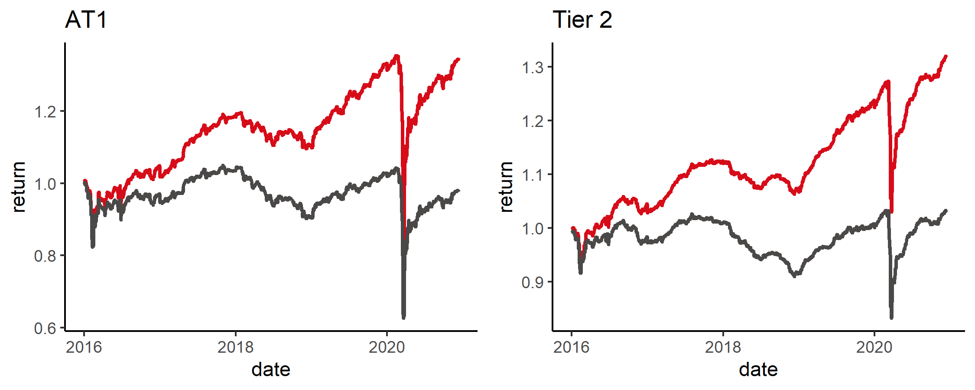

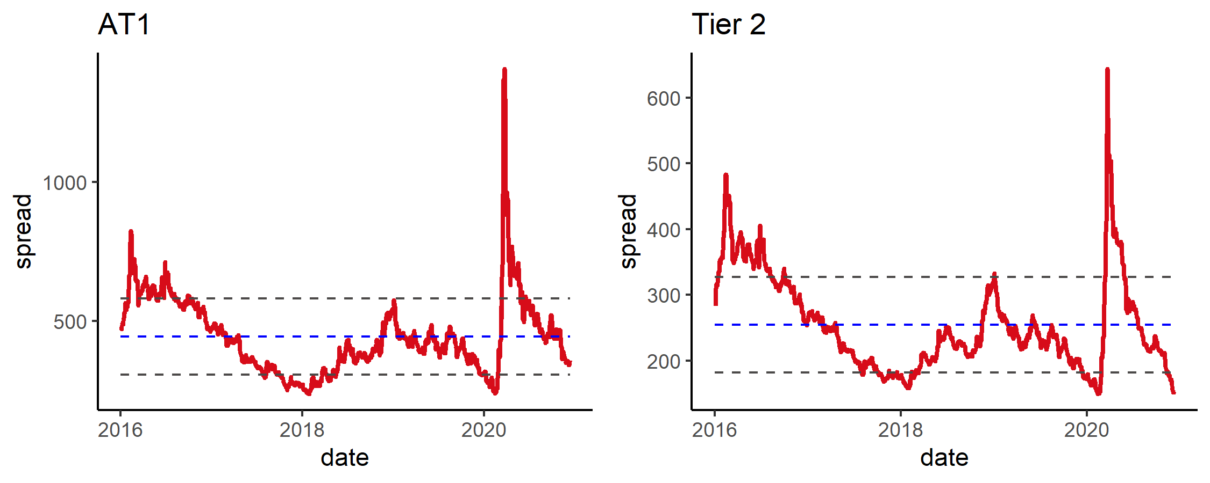

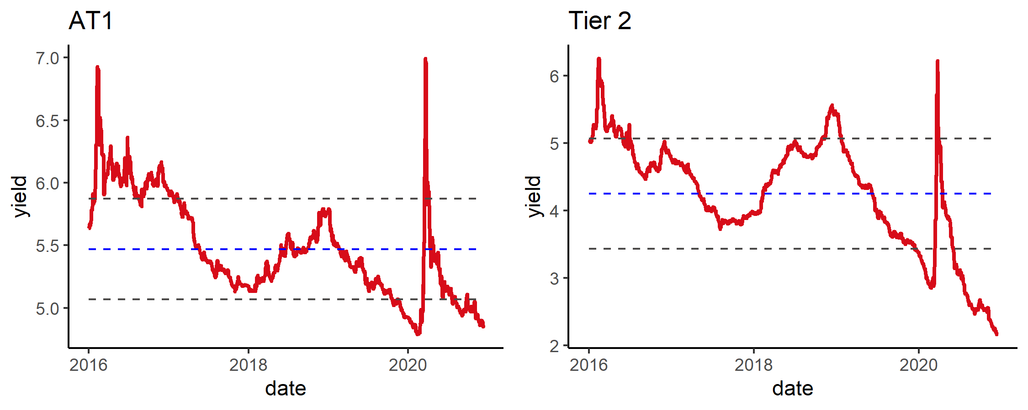

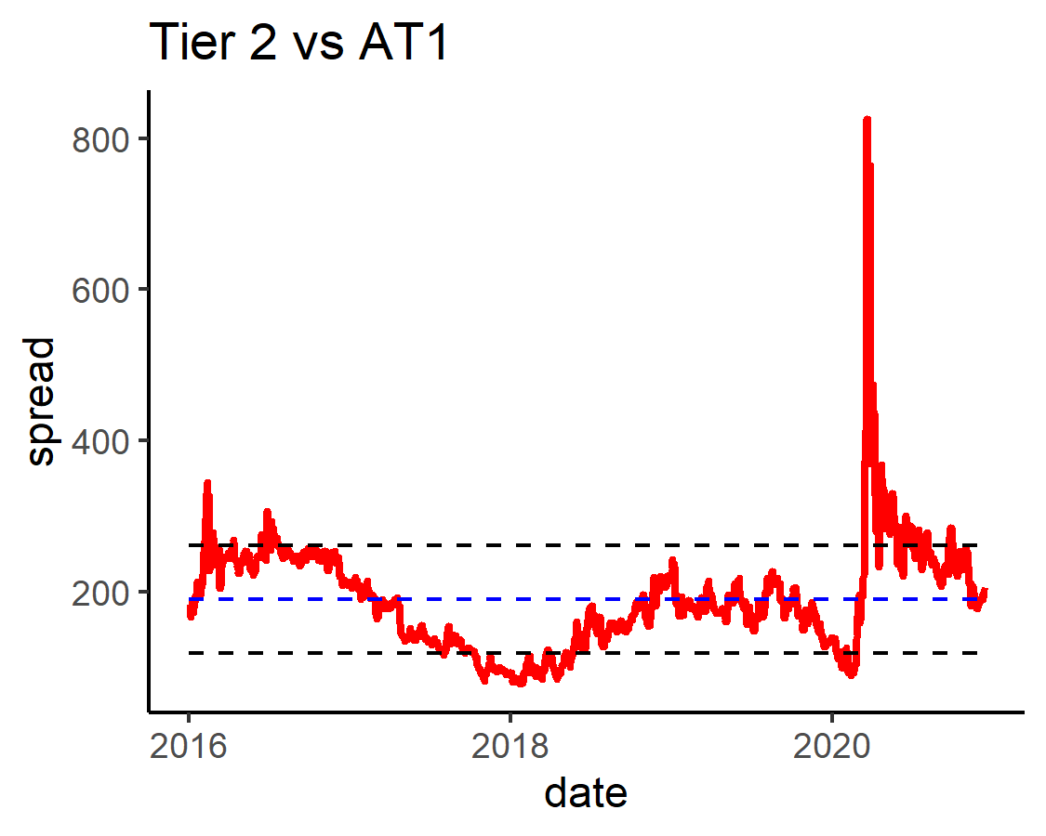

### 2)AT1 Summary

表65: Summary By rating2

| rating2 | Amount | weight | issues | YTM | spread | duration | price_chg | price_MTD | price_YTD | spread_chg | spread_MTD | spread_YTD |
| --- | --- | --- | --- | --- | --- | --- | --- | --- | --- | --- | --- | --- |
| B | 135,940 | 1.2% | 1 | 5.6 | 506 | 3.0 | -0.5% | -0.4% | -1.0% | 26 | 20 | 121 |
| BB | 6,512,103 | 59.1% | 43 | 5.0 | 375 | 3.3 | -0.2% | 0.2% | 1.6% | 18 | 3 | 25 |
| BBB | 4,372,495 | 39.7% | 34 | 4.6 | 332 | 3.7 | -0.1% | 0.4% | 2.4% | 15 | 0 | 72 |

表66: Summary of price_chg By rating2

| level1 | X0.1 | X1.3 | X3.5 | X5.10 |
| --- | --- | --- | --- | --- |
| BBB | -0.1% | -0.1% | -0.1% | -0.1% |
| BB | -0.1% | -0.2% | -0.1% | -0.2% |
| B |  |  | -0.5% |  |

表67: Summary of YTM By rating2

| level1 | X0.1 | X1.3 | X3.5 | X5.10 |
| --- | --- | --- | --- | --- |
| BBB | 5.37 | 4.53 | 4.65 | 4.04 |
| BB | 6.39 | 5.01 | 4.92 | 4.56 |
| B |  |  | 5.58 |  |

表68: Top 10

| Name | Rating | YTM | YTW | spread | duration | price_chg | spread_chg |
| --- | --- | --- | --- | --- | --- | --- | --- |
| MQGAU 6.125 PERP | BBB- | 4.3 | 4.9 | 401 | 5.1 | 0.4% | 2 |
| BAERVX 4.75 PERP | BBB- | 3.3 | 3.9 | 353 | 3.4 | 0.4% | -4 |
| ACAFP 8.125 PERP | BBB- | 5.8 | 3.4 | 309 | 4.1 | 0.4% | -2 |
| UBS 5 PERP | BB+ | 3.1 | 5.1 | 485 | 1.9 | 0.3% | -6 |
| WSTP 5 PERP | BBB+ | 3.5 | 4.2 | 330 | 5.7 | 0.2% | 6 |
| ANZ 6.75 PERP | BBB+ | 5.0 | 3.5 | 310 | 4.5 | 0.2% | 3 |
| SANTAN 7.5 PERP | BB+ | 5.2 | 4.0 | 358 | 2.8 | 0.2% | -4 |
| BNP 6.75 PERP | BBB- | 5.2 | 2.5 | 238 | 1.2 | 0.1% | -1 |
| INTNED 6.5 PERP | BB+ | 4.7 | 3.9 | 358 | 3.8 | 0.1% | 4 |
| INTNED 6.75 PERP | BB+ | 4.5 | 3.8 | 346 | 3.0 | 0.1% | 7 |

表69: Bottom 10

| Name | Rating | YTM | YTW | spread | duration | price_chg | spread_chg |
| --- | --- | --- | --- | --- | --- | --- | --- |
| BACR 6.125 PERP | BB | 5.8 | 4.4 | 404 | 4.2 | -1.1% | 34 |
| BACR 7.75 PERP | BB | 5.2 | 5.0 | 486 | 2.4 | -0.8% | 40 |
| BACR 8 PERP | BB | 5.8 | 4.6 | 424 | 3.0 | -0.7% | 33 |
| SOCGEN 5.375 PERP | BB | 4.8 | 4.7 | 380 | 7.7 | -0.7% | 18 |
| STANLN 7.5 PERP | BB+ | 6.5 | 3.9 | 382 | 1.2 | -0.6% | 54 |
| CS 5.1 PERP | BB+ | 3.9 | 4.5 | 365 | 7.1 | -0.5% | 17 |
| UCGIM 8 PERP | B+ | 5.6 | 5.4 | 506 | 3.0 | -0.5% | 26 |
| STANLN 6 PERP | BB+ | 5.6 | 4.3 | 397 | 3.9 | -0.5% | 21 |
| HSBC 6 PERP | BBB- | 4.2 | 4.4 | 356 | 5.3 | -0.5% | 18 |
| STANLN 7.75 PERP | BB+ | 5.8 | 3.8 | 368 | 2.1 | -0.5% | 30 |

表70: Top 10 MTD

| Name | Rating | YTM | YTW | spread | duration | price_chg | spread_chg |
| --- | --- | --- | --- | --- | --- | --- | --- |
| DB 4.789 PERP | BB | 5.1 | 6.2 | 576 | 3.8 | 1.6% | -35 |
| SOCGEN 5.375 PERP | BB | 4.8 | 4.7 | 380 | 7.7 | 1.5% | -22 |
| DB 7.5 PERP | BB | 5.5 | 5.8 | 542 | 3.6 | 1.3% | -23 |
| DB 6 PERP | BB | 5.2 | 6.0 | 555 | 4.1 | 1.1% | -21 |
| LLOYDS 7.5 PERP | BBB- | 4.8 | 4.3 | 398 | 4.0 | 1.1% | -22 |
| MQGAU 6.125 PERP | BBB- | 4.3 | 4.9 | 401 | 5.1 | 1.0% | -20 |
| WSTP 5 PERP | BBB+ | 3.5 | 4.2 | 330 | 5.7 | 1.0% | -20 |
| SANTAN 7.5 PERP | BB+ | 5.2 | 4.0 | 358 | 2.8 | 0.8% | -27 |
| LLOYDS 6.75 PERP | BBB- | 5.0 | 4.4 | 406 | 4.6 | 0.8% | -13 |
| LLOYDS 7.5 PERP | BBB- | 5.0 | 4.0 | 366 | 3.1 | 0.7% | -19 |

表71: Bottom 10 MTD

| Name | Rating | YTM | YTW | spread | duration | price_chg | spread_chg |
| --- | --- | --- | --- | --- | --- | --- | --- |
| UCGIM 8 PERP | B+ | 5.6 | 5.4 | 506 | 3.0 | -0.4% | 20 |
| STANLN 7.5 PERP | BB+ | 6.5 | 3.9 | 382 | 1.2 | -0.4% | 42 |
| STANLN 7.75 PERP | BB+ | 5.8 | 3.8 | 368 | 2.1 | -0.4% | 24 |
| BACR 8 PERP | BB | 5.8 | 4.6 | 424 | 3.0 | -0.3% | 14 |
| SHBASS 6.25 PERP | BBB | 3.9 | 3.1 | 266 | 2.9 | -0.2% | 6 |
| STANLN 6 PERP | BB+ | 5.6 | 4.3 | 397 | 3.9 | -0.2% | 10 |
| BACR 7.75 PERP | BB | 5.2 | 5.0 | 486 | 2.4 | -0.2% | 16 |
| BNP 7.625 PERP | BBB- | 6.6 | 1.7 | 161 | 0.3 | -0.1% | 51 |
| INTNED 6.875 PERP | BB+ | 5.4 | 3.1 | 296 | 1.3 | -0.1% | 16 |
| CS 7.125 PERP | BB+ | 5.4 | 3.5 | 334 | 1.5 | -0.1% | 14 |

表72: Top 10 YTD

| Name | Rating | YTM | YTW | spread | duration | price_chg | spread_chg |
| --- | --- | --- | --- | --- | --- | --- | --- |
| DB 7.5 PERP | BB | 5.5 | 5.8 | 542 | 3.6 | 17.0% | -96 |
| DANBNK 7 PERP | BB+ | 4.6 | 4.2 | 382 | 3.8 | 9.7% | 10 |
| SEB 5.125 PERP | BB+ | 3.9 | 4.0 | 365 | 3.9 | 8.8% | 29 |
| NDASS 6.625 PERP | BBB | 4.2 | 3.5 | 319 | 4.5 | 8.7% | 32 |
| DB 4.789 PERP | BB | 5.1 | 6.2 | 576 | 3.8 | 8.7% | -2,841 |
| SWEDA 5.625 PERP | BBB- | 4.4 | 3.7 | 330 | 3.4 | 8.5% | 15 |
| CS 6.375 PERP | BB+ | 4.9 | 4.1 | 372 | 4.7 | 8.4% | 51 |
| DANBNK 6.125 PERP | BB+ | 4.5 | 4.1 | 374 | 3.0 | 8.3% | 18 |
| WSTP 5 PERP | BBB+ | 3.5 | 4.2 | 330 | 5.7 | 8.1% | 37 |
| NDASS 6.125 PERP | BBB | 3.8 | 3.4 | 301 | 3.4 | 7.9% | 21 |

表73: Bottom 10 YTD

| Name | Rating | YTM | YTW | spread | duration | price_chg | spread_chg |
| --- | --- | --- | --- | --- | --- | --- | --- |
| BNP 7.625 PERP | BBB- | 6.6 | 1.7 | 161 | 0.30 | 2.9% | 41 |
| HSBC 6.875 PERP | BBB- | 5.8 | 2.9 | 276 | 0.46 | 3.0% | 126 |
| STANLN 7.5 PERP | BB+ | 6.5 | 3.9 | 382 | 1.23 | 3.3% | 162 |
| SOCGEN 7.375 PERP | BB | 6.5 | 3.1 | 300 | 0.72 | 3.5% | 111 |
| UBS 7.125 PERP | BB+ | 6.2 | 2.1 | 201 | 0.66 | 3.5% | 51 |
| HSBC 6.25 PERP | BBB- | 3.9 | 4.1 | 396 | 2.09 | 3.7% | 148 |
| INTNED 6.875 PERP | BB+ | 5.4 | 3.1 | 296 | 1.28 | 3.9% | 96 |
| NDASS 5.25 PERP | BBB | 3.6 | 2.5 | 234 | 0.75 | 4.0% | 44 |
| BNP 6.75 PERP | BBB- | 5.2 | 2.5 | 238 | 1.19 | 4.2% | 57 |
| CS 7.125 PERP | BB+ | 5.4 | 3.5 | 334 | 1.51 | 4.3% | 103 |

### 3)Tier2 Summary

表74: Summary By rating2

| rating2 | Amount | weight | issues | YTM | spread | duration | price_chg | price_MTD | price_YTD | spread_chg | spread_MTD | spread_YTD |
| --- | --- | --- | --- | --- | --- | --- | --- | --- | --- | --- | --- | --- |
| BB | 1,795,756 | 44.4% | 11 | 2.2 | 190 | 3.2 | 0.1% | 0.8% | 5.8% | 0 | -16 | -14 |
| BBB | 2,247,150 | 55.6% | 18 | 2.1 | 125 | 8.0 | 0.4% | 0.3% | 9.6% | 3 | -7 | -16 |

表75: Summary of price_chg By rating2

| level1 | X0.1 | X1.3 | X3.5 | X5.10 | X10. |
| --- | --- | --- | --- | --- | --- |
| BBB | 0.1% |  | 0.2% | 0.3% | 0.9% |
| BB |  | 0.1% | -0.1% | 0.1% |  |

表76: Summary of YTM By rating2

| level1 | X0.1 | X1.3 | X3.5 | X5.10 | X10. |
| --- | --- | --- | --- | --- | --- |
| BBB | 2.16 |  | 1.57 | 2.3 | 2.61 |
| BB |  | 1.65 | 2.26 | 3.68 |  |

表77: Top 10

| Name | Rating | YTM | YTW | spread | duration | price_chg | spread_chg |
| --- | --- | --- | --- | --- | --- | --- | --- |
| CBAAU 4.316 48 | BBB+ | 2.9 | 2.9 | 126 | 17.0 | 1.5% | 4 |
| WSTP 5 46 | BBB+ | 2.5 | 2.5 | 89 | 16.1 | 1.4% | 3 |
| CBAAU 3.743 39 | BBB+ | 2.5 | 2.5 | 88 | 13.8 | 1.4% | 2 |
| BBVASM 5.35 29 | BB | 3.5 | 3.6 | 327 | 3.5 | 0.8% | -14 |
| MQGAU 3.624 30 | BBB- | 2.5 | 2.5 | 165 | 8.1 | 0.7% | 1 |
| CBAAU 3.61 34 | BBB+ | 2.4 | 2.4 | 148 | 7.5 | 0.6% | 1 |
| BACR 7.625 22 | BB | 1.7 | 1.7 | 147 | 1.8 | 0.5% | -31 |
| CBAAU 4.5 25 | BBB+ | 1.4 | 1.4 | 107 | 4.5 | 0.5% | -4 |
| BBVASM 5.125 33 | BB | 3.6 | 4.0 | 312 | 5.8 | 0.5% | -3 |
| WSTP 4.11 34 | BBB+ | 2.3 | 2.3 | 142 | 7.2 | 0.4% | 4 |

表78: Bottom 10

| Name | Rating | YTM | YTW | spread | duration | price_chg | spread_chg |
| --- | --- | --- | --- | --- | --- | --- | --- |
| DB 5.882 31 | BB | 3.79 | 3.61 | 272 | 7.20 | -0.6% | 17 |
| CS 6.5 23 | BB+ | 1.57 | 1.57 | 140 | 2.43 | -0.4% | 23 |
| DB 4.5 25 | BB | 2.65 | 2.65 | 221 | 3.89 | -0.3% | 14 |
| UBS 5.125 24 | BB+ | 1.93 | 1.93 | 156 | 3.13 | 0.0% | 7 |
| ANZ 2.57 35 | BBB+ | 2.27 | 2.35 | 146 | 8.74 | 0.1% | 8 |
| CBAAU 3.375 26 | BBB+ | 2.16 | 1.32 | 120 | 0.84 | 0.1% | -2 |
| UBS 7.625 22 | BB+ | 0.93 | 0.93 | 81 | 1.57 | 0.1% | -2 |
| DB 4.875 32 | BB | 3.64 | 4.03 | 314 | 5.89 | 0.1% | 8 |
| ANZ 4.4 26 | BBB+ | 1.50 | 1.50 | 114 | 4.89 | 0.1% | 5 |
| ANZ 4.5 24 | BBB+ | 1.22 | 1.22 | 86 | 3.04 | 0.1% | 3 |

表79: Top 10 MTD

| Name | Rating | YTM | YTW | spread | duration | price_chg | spread_chg |
| --- | --- | --- | --- | --- | --- | --- | --- |
| BBVASM 5.35 29 | BB | 3.5 | 3.6 | 327 | 3.5 | 2.6% | -68 |
| DB 5.882 31 | BB | 3.8 | 3.6 | 272 | 7.2 | 2.4% | -35 |
| BBVASM 5.125 33 | BB | 3.6 | 4.0 | 312 | 5.8 | 2.2% | -37 |
| DB 4.875 32 | BB | 3.6 | 4.0 | 314 | 5.9 | 2.0% | -35 |
| DB 4.296 28 | BB | 2.8 | 3.0 | 281 | 2.3 | 1.8% | -69 |
| CBAAU 3.743 39 | BBB+ | 2.5 | 2.5 | 88 | 13.8 | 1.1% | -12 |
| MQGAU 3.624 30 | BBB- | 2.5 | 2.5 | 165 | 8.1 | 0.9% | -15 |
| BACR 7.625 22 | BB | 1.7 | 1.7 | 147 | 1.8 | 0.7% | -29 |
| CBAAU 4.316 48 | BBB+ | 2.9 | 2.9 | 126 | 17.0 | 0.6% | -8 |
| DB 4.5 25 | BB | 2.6 | 2.7 | 221 | 3.9 | 0.6% | -21 |

表80: Bottom 10 MTD

| Name | Rating | YTM | YTW | spread | duration | price_chg | spread_chg |
| --- | --- | --- | --- | --- | --- | --- | --- |
| WSTP 4.421 39 | BBB+ | 2.50 | 2.50 | 88 | 13.27 | -0.9% | 3 |
| CS 6.5 23 | BB+ | 1.57 | 1.57 | 140 | 2.43 | -0.4% | 19 |
| WSTP 2.668 35 | BBB+ | 2.26 | 2.31 | 142 | 8.69 | -0.1% | -2 |
| WSTP 2.963 40 | BBB+ | 2.49 | 2.49 | 86 | 15.16 | -0.1% | -5 |
| ANZ 2.57 35 | BBB+ | 2.27 | 2.35 | 146 | 8.74 | -0.1% | -2 |
| UBS 7.625 22 | BB+ | 0.93 | 0.93 | 81 | 1.57 | -0.0% | 4 |
| WSTP 5 46 | BBB+ | 2.52 | 2.52 | 89 | 16.12 | -0.0% | -4 |
| ANZ 4.5 24 | BBB+ | 1.22 | 1.22 | 86 | 3.04 | -0.0% | 1 |
| UBS 5.125 24 | BB+ | 1.93 | 1.93 | 156 | 3.13 | 0.1% | 0 |
| CBAAU 3.375 26 | BBB+ | 2.16 | 1.32 | 120 | 0.84 | 0.1% | -5 |

表81: Top 10 YTD

| Name | Rating | YTM | YTW | spread | duration | price_chg | spread_chg |
| --- | --- | --- | --- | --- | --- | --- | --- |
| WSTP 5 46 | BBB+ | 2.5 | 2.5 | 89 | 16.1 | 21.8% | -36 |
| CBAAU 3.743 39 | BBB+ | 2.5 | 2.5 | 88 | 13.8 | 20.7% | -46 |
| WSTP 4.421 39 | BBB+ | 2.5 | 2.5 | 88 | 13.3 | 19.9% | -44 |
| CBAAU 4.316 48 | BBB+ | 2.9 | 2.9 | 126 | 17.0 | 19.2% | -16 |
| DB 4.875 32 | BB | 3.6 | 4.0 | 314 | 5.9 | 15.8% | -70 |
| DB 4.5 25 | BB | 2.6 | 2.7 | 221 | 3.9 | 11.6% | -61 |
| WSTP 4.11 34 | BBB+ | 2.3 | 2.3 | 142 | 7.2 | 11.5% | -11 |
| ANZ 4.4 26 | BBB+ | 1.5 | 1.5 | 114 | 4.9 | 11.4% | -38 |
| CBAAU 3.61 34 | BBB+ | 2.4 | 2.4 | 148 | 7.5 | 11.3% | -5 |
| DB 4.296 28 | BB | 2.8 | 3.0 | 281 | 2.3 | 11.0% | -104 |

表82: Bottom 10 YTD

| Name | Rating | YTM | YTW | spread | duration | price_chg | spread_chg |
| --- | --- | --- | --- | --- | --- | --- | --- |
| CBAAU 3.375 26 | BBB+ | 2.16 | 1.32 | 120 | 0.84 | 3.8% | 3 |
| UBS 7.625 22 | BB+ | 0.93 | 0.93 | 81 | 1.57 | 4.9% | -19 |
| BACR 7.625 22 | BB | 1.68 | 1.68 | 147 | 1.82 | 5.3% | -2 |
| CS 6.5 23 | BB+ | 1.57 | 1.57 | 140 | 2.43 | 6.3% | 1 |
| UBS 5.125 24 | BB+ | 1.93 | 1.93 | 156 | 3.13 | 6.7% | 13 |
| ANZ 4.5 24 | BBB+ | 1.22 | 1.22 | 86 | 3.04 | 7.6% | -30 |
| MQGAU 4.875 25 | BBB- | 1.89 | 1.89 | 153 | 4.08 | 8.3% | 2 |
| BBVASM 5.35 29 | BB | 3.50 | 3.63 | 327 | 3.52 | 8.9% | 9 |
| CBAAU 4.5 25 | BBB+ | 1.43 | 1.43 | 107 | 4.53 | 9.5% | -17 |
| BBVASM 5.125 33 | BB | 3.65 | 4.00 | 312 | 5.85 | 9.6% | 6 |

## 8.EM

### 1)Index Review

图9: Return & Valuation

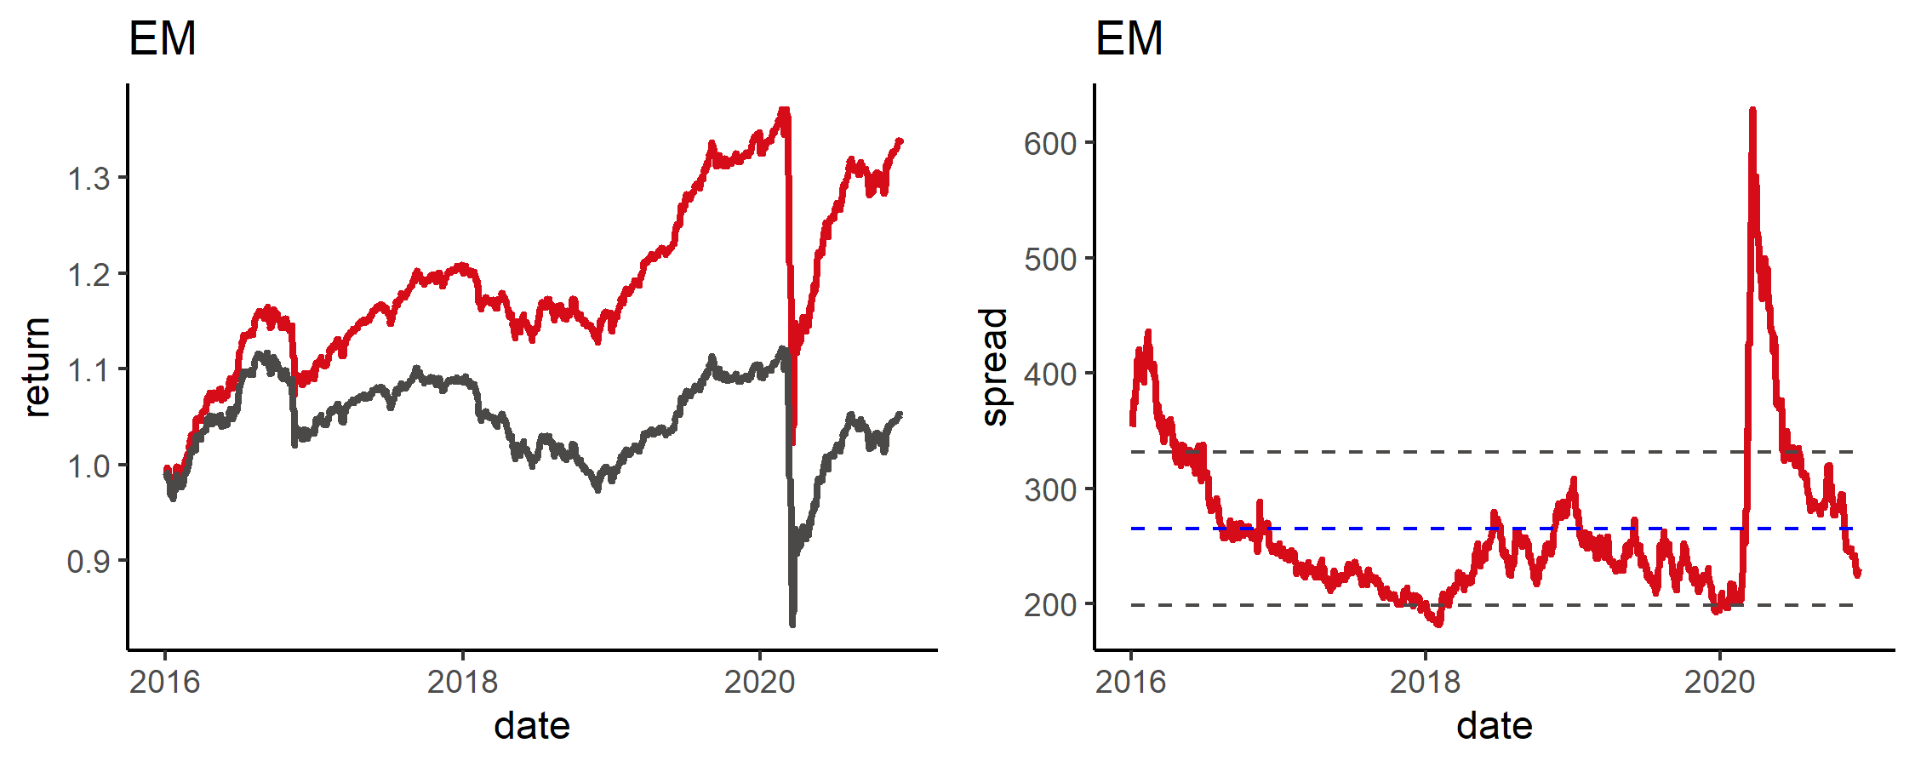

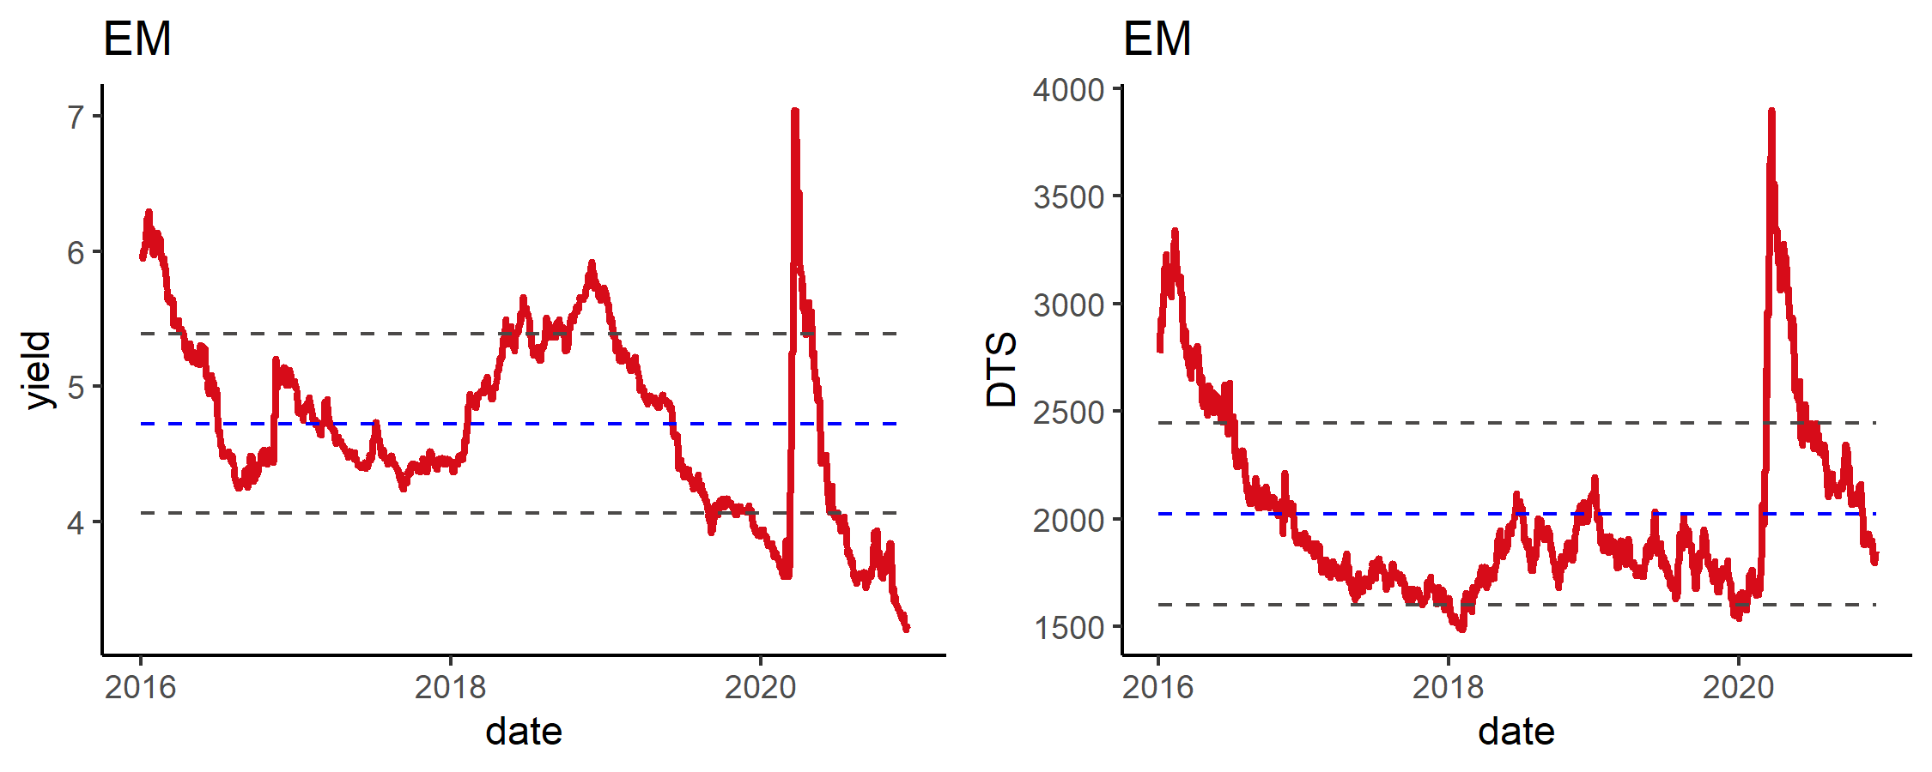

### 2)EM Summary

表83: Summary By rating2

| rating2 | Amount | weight | issues | YTM | spread | duration | price_chg | price_MTD | price_YTD | spread_chg | spread_MTD | spread_YTD |
| --- | --- | --- | --- | --- | --- | --- | --- | --- | --- | --- | --- | --- |
| A | 13,327,362 | 18.1% | 57 | 2.3 | 127 | 9.9 | 0.3% | 0.0% | 9.0% | 4 | -5 | 19 |
| AA | 13,500,648 | 18.3% | 50 | 1.7 | 79 | 9.5 | -0.0% | -0.2% | 8.6% | 7 | -2 | 4 |
| B | 14,545,390 | 19.7% | 129 | 5.4 | 460 | 5.8 | 0.2% | 2.3% | -1.8% | -4 | -39 | 96 |
| BB | 7,903,905 | 10.7% | 84 | 4.0 | 316 | 7.2 | -0.1% | 1.9% | 0.2% | 8 | -27 | 71 |
| BBB | 21,471,558 | 29.1% | 144 | 2.4 | 150 | 8.4 | -0.0% | 0.2% | 6.1% | 6 | -5 | 18 |
| CCC | 1,690,114 | 2.3% | 16 | 9.6 | 877 | 5.4 | -0.0% | 2.7% | -71.6% | 5 | -75 | 398 |
| NR | 1,373,192 | 1.9% | 10 | 3.1 | 257 | 5.5 | 0.2% | 0.4% | 4.7% | 1 | -13 | -87 |

表84: Summary By Label

| Label | Amount | weight | issues | YTM | spread | duration | price_chg | price_MTD | price_YTD | spread_chg | spread_MTD | spread_YTD |
| --- | --- | --- | --- | --- | --- | --- | --- | --- | --- | --- | --- | --- |
| Central Asia | 1,759,230 | 2.4% | 11 | 0.19 | 11 | 0.76 | -0.0% | 0.0% | 0.6% | 1 | 0 | 0 |
| Eastern Asia | 314,361 | 0.4% | 5 | 0.07 | 6 | 0.06 | 0.0% | 0.0% | 0.1% | 0 | -1 | 1 |
| Eastern Europe | 7,333,126 | 9.9% | 31 | 1.24 | 92 | 2.94 | 0.1% | 0.3% | 2.7% | 0 | -6 | 16 |
| Latin America and the Caribbean | 9,681,811 | 13.1% | 120 | 3.55 | 262 | 7.90 | 0.3% | 1.6% | 2.9% | 0 | -24 | 62 |
| Northern Africa | 3,608,283 | 4.9% | 26 | 1.34 | 113 | 1.66 | -0.1% | 0.5% | 1.4% | 1 | -8 | 25 |
| South-eastern Asia | 12,478,655 | 16.9% | 89 | 3.06 | 240 | 6.31 | 0.1% | 0.2% | 7.0% | 1 | -12 | -9 |
| Southern Asia | 1,366,601 | 1.9% | 15 | 3.62 | 341 | 1.20 | -0.0% | -0.4% | -29.6% | 2 | -47 | 94 |
| Southern Europe | 519,912 | 0.7% | 3 | 0.02 | 1 | 0.05 | 0.0% | 0.0% | 0.1% | 0 | 0 | 0 |
| Sub-Saharan Africa | 4,873,485 | 6.6% | 46 | 7.64 | 674 | 6.15 | 0.0% | 3.8% | -40.4% | 1 | -38 | 201 |
| Western Asia | 31,061,956 | 42.1% | 143 | 7.58 | 503 | 24.11 | -0.1% | 1.1% | 7.1% | 20 | -27 | 105 |

表85: Top 10

| Name | Rating | YTM | YTW | spread | duration | price_chg | spread_chg |
| --- | --- | --- | --- | --- | --- | --- | --- |
| ELSALV 7.65 35 | B- | 8.5 | 8.5 | 764 | 8.1 | 3.0% | -31 |
| ELSALV 7.1246 50 | B- | 8.2 | 8.2 | 654 | 10.9 | 2.9% | -12 |
| ELSALV 7.625 41 | B- | 8.6 | 8.5 | 694 | 9.4 | 2.8% | -13 |
| CFELEC 5.75 42 | BBB | 4.4 | 4.4 | 282 | 12.7 | 2.7% | -8 |
| COSTAR 6.125 31 | B | 6.9 | 6.9 | 607 | 6.7 | 2.6% | -27 |
| ZAMBIN 8.97 27 | NR | 22.9 | 22.9 | 2,388 | 3.2 | 2.6% | -189 |
| ELSALV 9.5 52 | B- | 9.5 | 9.5 | 786 | 9.6 | 2.6% | -12 |
| ELSALV 8.25 32 | B- | 8.8 | 8.7 | 785 | 7.1 | 2.5% | -24 |
| COSTAR 7.158 45 | B | 7.6 | 7.6 | 601 | 10.9 | 2.4% | -49 |
| MEXCAT 5.5 46 | BBB- | 5.3 | 5.3 | 369 | 13.6 | 2.3% | -4 |

表86: Bottom 10

| Name | Rating | YTM | YTW | spread | duration | price_chg | spread_chg |
| --- | --- | --- | --- | --- | --- | --- | --- |
| CFELEC 5.15 47 | BBB | 5.0 | 4.8 | 395 | 8.9 | -8.0% | 99 |
| OMAN 6.75 48 | BB- | 7.0 | 7.0 | 535 | 11.8 | -1.8% | 28 |
| OMAN 6.5 47 | BB- | 6.8 | 6.8 | 517 | 12.0 | -1.7% | 26 |
| PLNIJ 6.25 49 | BBB | 4.2 | 4.2 | 256 | 14.9 | -1.5% | 14 |
| EGYPT 7.903 48 | B | 7.3 | 7.3 | 568 | 11.3 | -1.5% | 3 |
| INDON 4.625 43 | BBB | 3.3 | 3.3 | 169 | 14.6 | -1.5% | 23 |
| PLNIJ 5.25 42 | BBB | 4.0 | 4.0 | 241 | 13.6 | -1.5% | 23 |
| EGYPT 8.875 50 | B | 7.6 | 7.6 | 598 | 11.4 | -1.5% | 26 |
| PERTIJ 6.45 44 | BBB | 4.1 | 4.1 | 243 | 13.7 | -1.3% | 15 |
| PLNIJ 6.15 48 | BBB | 4.2 | 4.2 | 257 | 14.9 | -1.3% | 21 |

表87: Top 10 MTD

| Name | Rating | YTM | YTW | spread | duration | price_chg | spread_chg |
| --- | --- | --- | --- | --- | --- | --- | --- |
| ZAMBIN 8.97 27 | NR | 22.9 | 22.9 | 2,388 | 3.2 | 9.7% | -222 |
| COSTAR 7.158 45 | B | 7.6 | 7.6 | 601 | 10.9 | 8.4% | -79 |
| COSTAR 7 44 | B | 7.6 | 7.6 | 598 | 10.8 | 8.3% | -75 |
| COSTAR 5.625 43 | B | 6.8 | 6.8 | 520 | 11.8 | 7.8% | -67 |
| COSTAR 6.125 31 | B | 6.9 | 6.9 | 607 | 6.7 | 6.8% | -108 |
| ANGOL 9.125 49 | CCC+ | 10.1 | 10.0 | 842 | 9.4 | 6.4% | -68 |
| ANGOL 9.375 48 | CCC+ | 10.1 | 10.1 | 850 | 8.8 | 6.2% | -65 |
| ELSALV 7.1246 50 | B- | 8.2 | 8.2 | 654 | 10.9 | 6.0% | -55 |
| ELSALV 7.65 35 | B- | 8.5 | 8.5 | 764 | 8.1 | 5.9% | -70 |
| GHANA 8.75 61 | B- | 8.4 | 8.4 | 679 | 11.1 | 5.8% | -52 |

表88: Bottom 10 MTD

| Name | Rating | YTM | YTW | spread | duration | price_chg | spread_chg |
| --- | --- | --- | --- | --- | --- | --- | --- |
| CFELEC 5.15 47 | BBB | 5.0 | 4.8 | 395 | 8.9 | -5.0% | 53 |
| SRILAN 6.825 26 | CCC+ | 19.1 | 19.1 | 1,870 | 3.9 | -3.5% | 102 |
| SRILAN 6.125 25 | CCC+ | 19.4 | 19.4 | 1,904 | 3.5 | -2.9% | 103 |
| SRILAN 6.85 25 | CCC+ | 19.6 | 19.6 | 1,910 | 3.6 | -2.6% | 76 |
| SHJGOV 4 50 | BBB- | 3.9 | 3.9 | 230 | 17.1 | -2.6% | 12 |
| SRILAN 6.85 24 | CCC+ | 23.9 | 23.9 | 2,350 | 2.5 | -2.6% | 130 |
| SRILAN 6.2 27 | CCC+ | 17.4 | 17.4 | 1,647 | 4.5 | -2.3% | 58 |
| SRILAN 6.75 28 | CCC+ | 17.0 | 17.0 | 1,601 | 4.9 | -2.3% | 46 |
| SRILAN 5.75 23 | CCC+ | 25.4 | 25.4 | 2,523 | 1.9 | -2.2% | 158 |
| SRILAN 7.85 29 | CCC+ | 17.6 | 17.6 | 1,674 | 4.9 | -2.1% | 49 |

表89: Top 10 YTD

| Name | Rating | YTM | YTW | spread | duration | price_chg | spread_chg |
| --- | --- | --- | --- | --- | --- | --- | --- |
| DPWDU 4.7 49 | BBB- | 3.9 | 3.9 | 230 | 16.2 | 16.9% | -1 |
| IVYCST 6.125 33 | B+ | 4.7 | 4.6 | 373 | 8.2 | 16.7% | -32 |
| CDEL 3.7 50 | A | 3.2 | 3.2 | 151 | 17.9 | 16.3% | -1 |
| KZOKZ 5.75 47 | BBB- | 3.7 | 3.7 | 211 | 15.2 | 16.0% | -4 |
| BMETR 5 47 | A- | 3.4 | 3.4 | 174 | 15.5 | 16.0% | -1 |
| GUATEM 6.125 50 | BB- | 4.2 | 4.2 | 260 | 15.5 | 15.8% | 0 |
| KZOKZ 6.375 48 | BBB- | 3.8 | 3.8 | 221 | 15.3 | 15.7% | -1 |
| CDEL 4.375 49 | A | 3.2 | 3.2 | 155 | 16.9 | 15.7% | 0 |
| MALAYS 4.08 46 | A- | 2.3 | 2.3 | 68 | 17.1 | 15.5% | 0 |
| QATAR 4.817 49 | AA- | 2.9 | 2.9 | 124 | 17.2 | 15.2% | 5 |

表90: Bottom 10 YTD

| Name | Rating | YTM | YTW | spread | duration | price_chg | spread_chg |
| --- | --- | --- | --- | --- | --- | --- | --- |
| SRILAN 7.85 29 | CCC+ | 18 | 18 | 1,674 | 4.9 | -35.5% | 1,104 |
| SRILAN 7.55 30 | CCC+ | 16 | 16 | 1,558 | 5.3 | -34.3% | 984 |
| SRILAN 6.825 26 | CCC+ | 19 | 19 | 1,870 | 3.9 | -33.9% | 1,333 |
| SRILAN 6.75 28 | CCC+ | 17 | 17 | 1,601 | 4.9 | -33.2% | 1,054 |
| SRILAN 6.85 25 | CCC+ | 20 | 20 | 1,910 | 3.6 | -32.8% | 1,402 |
| SRILAN 6.2 27 | CCC+ | 17 | 17 | 1,647 | 4.5 | -32.5% | 1,114 |
| SRILAN 6.85 24 | CCC+ | 24 | 24 | 2,350 | 2.5 | -31.9% | 1,883 |
| SRILAN 6.125 25 | CCC+ | 19 | 19 | 1,904 | 3.5 | -31.0% | 1,402 |
| SRILAN 6.35 24 | CCC+ | 22 | 22 | 2,143 | 2.7 | -30.6% | 1,668 |
| SRILAN 5.75 23 | CCC+ | 25 | 25 | 2,523 | 1.9 | -27.3% | 2,087 |

### 3)Duration Matrix

表91: Duration Matrix for spread_chg By Label

| level1 | X0.1 | X1.3 | X3.5 | X5.10 | X10. |
| --- | --- | --- | --- | --- | --- |
| Central Asia |  |  |  |  | 8 |
| Eastern Europe |  | -3 | 4 | -1 | 7 |
| Latin America and the Caribbean |  | -16 | -11 | 2 | 5 |
| Northern Africa |  |  | -3 | 6 | 18 |
| other |  |  |  | -5 |  |
| South-eastern Asia |  | 1 | 3 | 8 | 14 |
| Sub-Saharan Africa |  |  | -17 | -3 | 2 |
| Western Asia | 2 | -2 | 4 | 7 | 11 |

表92: Duration Matrix for spread By Label

| level1 | X0.1 | X1.3 | X3.5 | X5.10 | X10. |
| --- | --- | --- | --- | --- | --- |
| Central Asia |  |  |  |  | 172 |
| Eastern Europe |  | 147 | 293 | 298 | 171 |
| Latin America and the Caribbean |  | 262 | 294 | 316 | 305 |
| Northern Africa |  |  | 427 | 484 | 550 |
| other |  |  |  | 363 |  |
| South-eastern Asia |  | 145 | 85 | 131 | 186 |
| Sub-Saharan Africa |  |  | 576 | 582 | 585 |
| Western Asia | 84 | 161 | 176 | 159 | 173 |

表93: Duration Matrix for spread_chg By rating2

| level1 | X1.3 | X3.5 | X5.10 | X10. |
| --- | --- | --- | --- | --- |
| AA | 1 | 5 | 7 | 10 |
| A | -4 | 3 | 2 | 9 |
| BBB | 2 | 3 | 7 | 10 |
| BB | -1 | 1 | 12 | 16 |
| B | -10 | -7 | -3 | 6 |
| CCC |  | 7 | 1 |  |
| NR | -5 |  |  |  |

表94: Duration Matrix for spread By rating2

| level1 | X1.3 | X3.5 | X5.10 | X10. |
| --- | --- | --- | --- | --- |
| AA | 37 | 56 | 68 | 119 |
| A | 47 | 80 | 144 | 152 |
| BBB | 82 | 112 | 156 | 201 |
| BB | 207 | 283 | 333 | 382 |
| B | 396 | 420 | 489 | 565 |
| CCC |  | 1214 | 805 |  |
| NR | 315 |  |  |  |